**MEDICAL STORE MANAGEMENT SYSTEM**

**A MINIPROJECT REPORT**

***Submitted by***

**THARANI M.N (953620104057)**

**SARUMATHI M (953620104043)**

**BACHELOR OF ENGINEERING**

**IN**

COMPUTER SCIENCE AND ENGINEERING

**RAMCO INSTITUTE OF TECHNOLOGY,**

**RAJAPALAYAM**

**JUNE 2022**

**BONAFIDE CERTIFICATE**

Certified that this miniproject report **“MEDICAL STORE MANAGEMENT SYSTEM”** is the bonafide work of **“THARANI M.N (953620104057) , SARUMATHI M (953620104043)** who carriedOut the miniproject work under our supervision.

|  |  |
| --- | --- |
| **SIGNATURE**  Dr.K.Vijayalakshmi M.E., Ph.D.  **HEAD OF THE DEPARTMENT**  Department of Computer Science  and Engineering  Ramco Institute of Technology  North Venganallur Village  Rajapalayam – 626117 | **SIGNATURE**  Mr.K.VigneshSaravanan B.E.,M.Tech.  **FACULTY IN CHARGE**  Assistant Professor  Department of Computer Science and Engineering  Ramco Institute of Technology  North Venganallur Village  Rajapalayam– 626117 |

**INTERNAL EXAMINER EXTERNAL EXAMINER**

**TABLE OF CONTENTS**

|  |  |  |
| --- | --- | --- |
| **CHAPTER NO.** | **TITLE** | **PAGE NO.** |
|  | ABSTRACT | 4 |
|  | LIST OF FIGURES | 5 |
| 1 | INTRODUCTION | 6 |
| 2 | PROJECT DESCRIPTION | 7 |
|  | 2.1 SYSTEM SPECIFICATION | 8 |
|  | 2.2 ER DIAGRAM | 9 |
| 3 | DATABASE DESIGN | 10 |
| 4 | SOURCE CODE | 14 |
| 5 | SCREENSHOTS | 85 |
| 6 | CONCLUSION | 91 |
| 7 | REFERENCES | 92 |

**ABSTRACT**

This report describes our group's implementation of MEDICAL STORE management system. We used the Entity-Relationship model to design a database that will store and organize customers and sellers data. We have created the database using SQL and populated it with some sample data. The system can keep track of customer details, vendor details, availability of stocks, product details and corresponding relationship between them. Using HTML, CSS, Javascript and PHP. we have created graphical user interface that allows the customers and sellers to access the system remotely. This system is hosted on Apache server using Xampp.

**LIST OF FIGURES**

|  |  |  |
| --- | --- | --- |
| 5.1 | HOME PAGE | 85 |
| 5.2 | LOGIN PAGE | 86 |
| 5.3 | REGISTER AS VENDOR | 86 |
| 5.4 | VENDOR INFORMATION | 87 |
| 5.5 | ADDING PRODUCTS | 87 |
| 5.6 | RESTOCK | 88 |
| 5.7 | ORDER DETAILS FOR PRODUCTS | 88 |
| 5.8 | REGISTER AS CUSTOMER | 89 |
| 5.9 | CUSTOMER INFORMATION | 89 |
| 5.10 | PURCHASE PAGE FOR CUSTOMER | 90 |
| 5.11 | ORDER DETAILS OF CUSTMER | 90 |

|  |
| --- |
|  |

**CHAPTER 1**

**INTRODUCTION**

This report provides a detailed account of the processes which our group has used to design and implement a database that can be used to manage **medical shop** system. The main objective of the project is to purchase medicine online. This system is handled by the sellers for creating and updating the medicines and used by customers for buying the medicines online. Separate registrations are available for customers and vendor. Each customer and vendor have unique user id and password for login and in case of new customer or vendor new registration is available. The user can easily order medicine from their seller through online. The seller can easily check the available stocks and the medicine stock can be modified using restock option. The changes are made by the sellers for the products.

**CHAPTER 2**

**PROJECT DESCRIPTION**

The project Medical Store Management System includes registration of customers and vendors. The vendors and customers have different id and password. Once registration is completed, the page will be redirected to login page and it will show error if the customer or vendor already registered during registration. If a customer buys a medicine the purchased product will be added to the product table. In our project the restock option is available for the sellers and the seller restocks the products. There are multiple sellers in our project and each seller has unique seller id. The details of the orders that the customers make will be displayed in the orders of the particular seller. The information will be safe. This system helps to check the available stocks of the medicines easily. This system is not complicated to implement and it is user friendly.

Functions for seller:

1. Login
2. Register for vendor
3. Add new product
4. Check the availability of stocks and restock the product if it is out of stock

**2.1 SYSTEM SPECIFICATION**

**2.1.1. HARDWARE SPECIFICATION**

* Processor : Intel dual core
* Processor speed : 1.04GHZ
* RAM : 4GB
* Hard disc : 20GB hard disc
* Monitor : LCD
* Keyboard : MM Keyboard(Usb)
* Mouse : Optical mouse(Usb)

**2.1.2. SOFTWARE SPECIFICATION:**

* OS : Window 10
* Language : Html, CSS, Java script, SQL queries
* Software used : Xampp,PHPMyAdmin

**2.2**  ER diagram

Medical Store Management

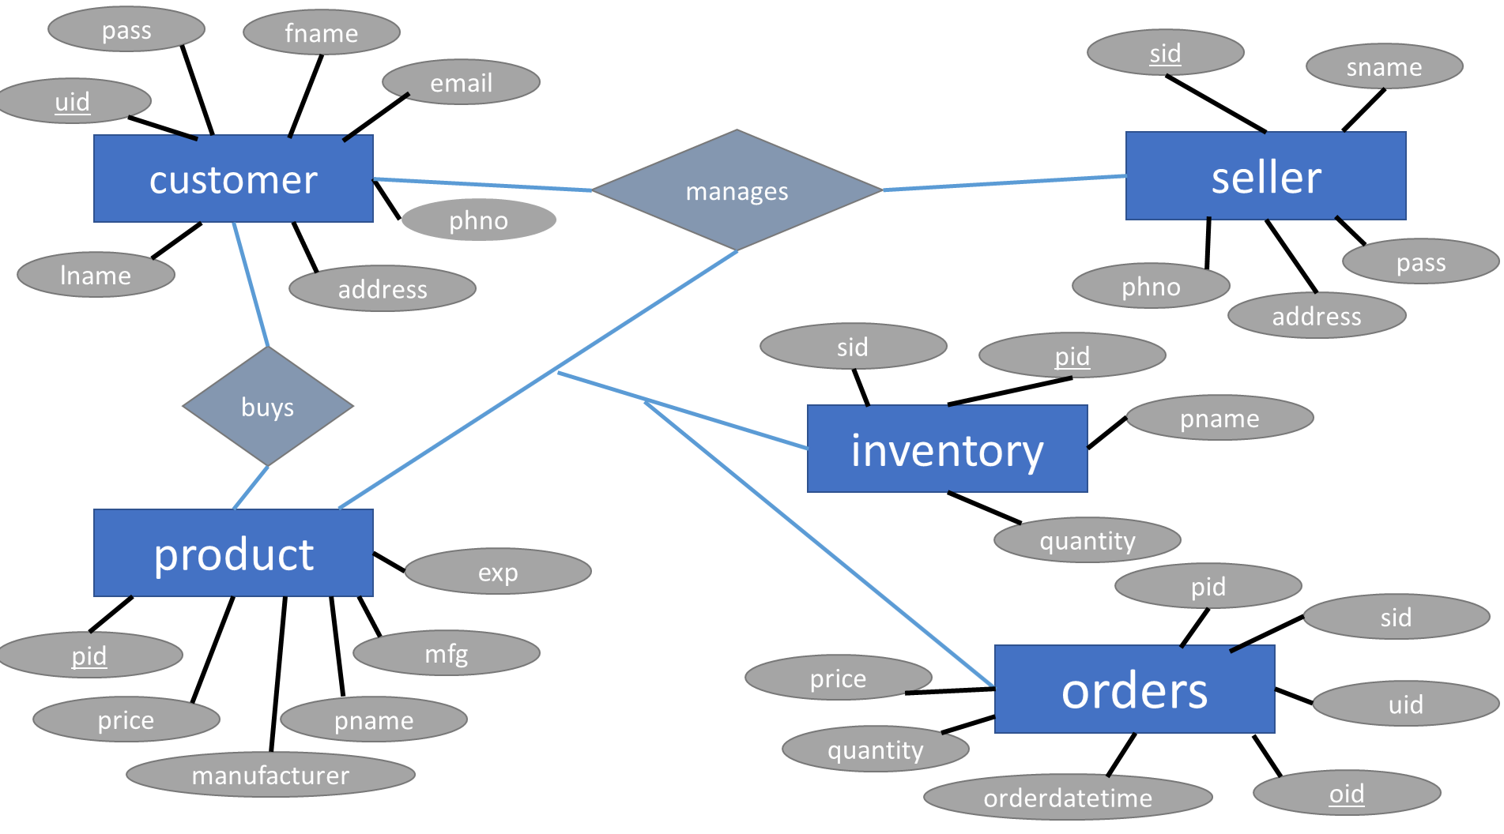

**Chapter 3**

**DATABASE DESIGN**

CREATE TABLE customer (

uid varchar(20) NOT NULL,

pass varchar(20) DEFAULT NULL,

fname varchar(15) DEFAULT NULL,

lname varchar(15) DEFAULT NULL,

email varchar(30) DEFAULT NULL,

address varchar(128) DEFAULT NULL,

phno bigint DEFAULT NULL,

PRIMARY KEY (uid)

);

CREATE TABLE seller (

sid varchar(15) NOT NULL,

sname varchar(20) DEFAULT NULL,

pass varchar(20) DEFAULT NULL,

address varchar(128) DEFAULT NULL,

phno bigint DEFAULT NULL,

PRIMARY KEY (sid)

);

CREATE TABLE product (

pid varchar(15) NOT NULL,

pname varchar(20) DEFAULT NULL,

manufacturer varchar(20) DEFAULT NULL,

mfg date DEFAULT NULL,

exp date DEFAULT NULL,

price int DEFAULT NULL,

PRIMARY KEY (pid),

);

CREATE TABLE inventory (

pid varchar(15) NOT NULL,

pname varchar(20) DEFAULT NULL,

quantity int DEFAULT NULL,

sid varchar(15) NOT NULL,

PRIMARY KEY (pid,sid),

FOREIGN KEY (pid) REFERENCES product (pid),

FOREIGN KEY (sid) REFERENCES seller (sid)

);

CREATE TABLE orders (

oid int NOT NULL IDENTITY(1000,1),

pid varchar(15) DEFAULT NULL,

sid varchar(15) DEFAULT NULL,

uid varchar(20) DEFAULT NULL,

orderdatetime datetime DEFAULT NULL,

quantity int DEFAULT NULL,

price int DEFAULT NULL,

PRIMARY KEY (oid),

FOREIGN KEY (pid) REFERENCES product (pid),

FOREIGN KEY (sid) REFERENCES seller (sid),

FOREIGN KEY (uid) REFERENCES customer (uid)

); END

CREATE TRIGGER updatetime ON orders INSTEAD OF INSERT AS

BEGIN

declare @o int

declare @p varchar(15)

declare @u varchar(20)

declare @s varchar(15)

declare @ordt datetime

declare @q int

declare @pri int

select @o=i.oid from inserted i;

select @p=i.pid from inserted i;

select @u=i.uid from inserted i;

select @s=i.sid from inserted i;

select @q=i.quantity from inserted i;

select @pri=i.price from inserted i;

update orders set orderdatetime=Getdate() where oid=@o;

END

go

enable trigger updatetime on orders

CREATE TRIGGER inventorytrigger ON orders AFTER INSERT as

begin

DECLARE @qnty int;

DECLARE @productid varchar(20);

select @productid=i.pid from inserted i order by oid desc

select @qnty=i.quantity from inserted i order by oid desc

UPDATE inventory

SET quantity=quantity-@qnty

WHERE pid=@productid;

END

go

enable trigger inventorytrigger on orders

CREATE PROCEDURE getsellerorders(@param1 VARCHAR(20)) as

BEGIN

SELECT * FROM orders where sid=@param1;

CREATE PROCEDURE getorders(@param1 VARCHAR(20)) as

BEGIN

SELECT * FROM orders WHERE uid=@param1;

END

**SELLER TABLE**

insert into seller values('101','Dan','123','London',1234567890);

insert into seller values('102','Ron','456','France',4567891230);

insert into seller values('103','Hermione','789','Paris',7894561230);

insert into seller values('104','Ginny','741','Maldives',1237894560);

insert into seller values('105','Luna','852','Hawei',7894123560);

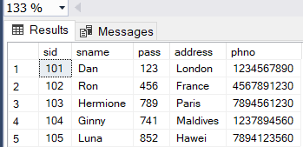

**PROUDUCT TABLE**

insert into product values('201','paracetamol','Apollo','2020-08-10','2024-09-14',50);

insert into product values('202','volini','siphla','2020-08-10','2024-09-14',26);

insert into product values('203','gelicil','Bharath','2020-08-10','2024-09-14',26);

insert into product values('204','pan-d','Apollo','2020-08-10','2024-09-14',48);

insert into product values('205','vaseline','Apollo','2020-08-10','2024-09-14',63);

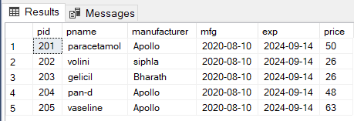

**INVENTORY TABLE**

insert into inventory values('201','paracetamol',10,'101');

insert into inventory values('202','volini',15,'101');

insert into inventory values('203','gelicil',10,'102');

insert into inventory values('204','pan-d',15,'102');

insert into inventory values('205','vaseline',12,'103');

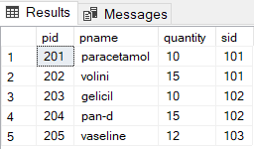

**CUSTOMER TABLE**

insert into customer values('106','1230','fred','weasely','123@gamil.com','Dubai',1234567890);

insert into customer values('107','4560','george','weasely','234@gmail.com','Orlando',2345678910);

insert into customer values('108','7890','draco','malfoy','789@gmail.com','greece',4567891230);

insert into customer values('109','7410','lily','evans','987@gmail.com','Swizerland',7894561230);

insert into customer values('110','8520','james','potter','654@gmail.com','New York',4567891230);

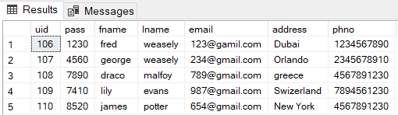

**ORDER TABLE**

insert into orders values(1000,'201','101','106','2022-06-18 18:54:29',5,250);

insert into orders values(1001,'202','101','107','2022-06-18 18:55:20',1,26);

insert into orders values(1002,'203','102','108','2022-06-18 18:55:52',2,52);

insert into orders values(1003,'204','102','108','2022-06-18 18:56:06',10,480);

insert into orders values(1004,'205','103','109','2022-06-18 18:56:55',2,126);

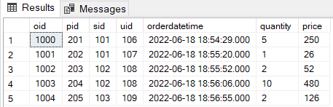

**CHAPTER 4**

**CSS CODE**

**login**

body{

margin: 0;

padding: 0;

font-family:sans-serif;

background-image: url("../images/bg.png");

background-color: #78e4ff;

background-repeat: no-repeat;

}

.container

{

width: 50%;

display: flex;

align-items: center;

height: 720px;

}

.loginbox{

width: 320px;

height: auto;

box-sizing: border-box;

padding: 40px 30px;

background: rgba(255,250,250,0.85);

margin:0 auto;

}

h2{

position:relative;

margin :0 auto;

color: #2f4f4f;

font-size: 22px;

padding: 0 0 20px;

}

h3{

position:relative;

margin :0 auto;

color: #ff2929;

font-size: 18px;

padding: 0 0 20px;

}

.customselect select{

width: 100%;

height: 100%;

background: none;

border: none;

-webkit-appearance: none;

cusrsor: pointer;

text-indent: 5px;

}

.customselect select:focus{

outline: none;

}

.customselect option{

font-size: 16px;

}

.customselect .select{

position: relative;

background: #fff;

border: 1px solid #1d67b1;

height: 20px;

cursor: pointer;

}

.customselect .select:before{

content: '';

background: #1d67b1;

position: absolute;

top: -1px;

bottom: 0;

right:-1px;

width: 40px;

pointer-events: none;

}

.customselect .select:after{

content: '';

width: 0;

height: 0;

border-style: solid;

border-width: 10px 7px 0;

border-color: #fff transparent transparent transparent;

position: absolute;

top: 50%;

right: 11px;

transform: translateY(-50%);

pointer-events: none;

}

.loginbox input{

width:100%;

margin-bottom:30px;

}

.loginbox input[type="text"],.loginbox input[type="password"]

{

position:relative;

border: none;

padding-top: 20px;

border-bottom: 1px solid #808080;

outline: none;

color: black;

height: 30px;

background: transparent;

font-size: 18px;

}

::placeholder

{

font-size:16px;

color: #808080;

}

.loginbox input[type="submit"]

{

margin: 0 25px;

border: none;

outline: none;

border-radius: 20px;

color: #fff;

background: #090adc;

height: 40px;

width: 80%;

font-size:18px;

cursor: pointer;

}

.loginbox input[type="submit"]:hover

{

background: #04e4e4;

color: #262626;}

**INDEX**

body{

margin: 0;

padding: 0;

font-family: sans-serif;

background-image: url("../images/bg.png");

background-color: #78e4ff;

background-repeat: no-repeat;

}

.container

{

width: 50%;

display: flex;

align-items: center;

height: 720px;

}

.indexbox{

width: 320px;

height: auto;

padding:30px 30px;

box-sizing: border-box;

background: rgba(255,250,250,0.85);

margin: 0 auto;

}

h2{

top:-20%;

margin: 0 auto;

padding: 0 0 40px;

color:#2f4f4f;

font-size:22px;

}

.indexbox button

{

width: 100%;

margin-bottom: 40px;

}

.button1{

position: realtive;

align: center;

border: none;

outline: none;

height: 40px;

width: 64%;

color: #fff;

font-size: 18px;

background: #090adc;

cursor: pointer;

border-radius: 20px;

button1:hover{

color: #262626;

background: #04e4e4;

}

}

**Home page**

body{

margin: 0;

padding: 0;

font-family: sans-serif;

background: white;

}

.main{

margin: 0 auto;

width: 100%;

height: auto;

}

.topbar1{

width: 100%;

height: 4px;

background-color: #fcc508;

}

.topbar2{

width: 100%;

height: 30px;

background-color: #2a2b2c;

}

.container1{

width: 1000px;

height: 30px;

background-color: transparent;

margin: 0 auto;

}

.container2{

width: 1000px;

height: 30px;

background-color: transparent;

margin: 0 auto;

}

.logout-btn{

width: 150px;

height: 30px;

float: right;

}

.logout-btn a{

display: block;

color: white;

text-decoration: none;

padding: 4px;

}

.header{

width: 100%;

height: 40px;

float: left;

background-color:#0ca1a6;

box-shadow: 0 0, 0 6px 20px 0 rgba(0, 0, 0, .14);

}

.navbar{

width: 700px;

float: left;

text-align: left;

padding-top:10px;

padding-bottom: 10px;

}

.navbar a{

display: inline-block;

color: black;

text-decoration:none;

padding: 0 10px;

font-weight:bold;

}

.navbar a:hover{

color: white;

background-color: black;

padding: 0 10px;

}

.active{

width:1000px;

min-height:688px;

background-color: white;

margin: 0 auto;

padding: 0px 20px 0px 20px;

}

.filler{

width:100%;

height:50px;

backgroud-color: transparent;

}

.filler2{

width:100%;

height:30px;

backgroud-color: transparent;

}

h2{

text-align: center;

padding: 20px 0 20px 0;

}

.card {

width:340px;

height: auto;

box-shadow: 0 4px 8px 0 rgba(0,0,0,0.2);

transition: 0.3s;

margin: 0 auto;

text-align:center;

padding: 4px 0 10px 0;

}

.card:hover {

box-shadow: 0 8px 16px 2px rgba(0,0,0,0.2);

}

.space1{

font-size:24px;

}

.filler3{

width:auto;

height:10px;

}

.space{

padding-top:10px;

}

**Orders:**

body{

margin: 0;

padding: 0;

font-family: sans-serif;

background-image: url("b2g.png");

background-repeat: no-repeat;

}

.main{

margin: 0 auto;

width: 100%;

height: auto;

}

.topbar1{

width: 100%;

height: 4px;

background-color: #fcc508;

}

.topbar2{

width: 100%;

height: 30px;

background-color: #2a2b2c;

}

.container1{

width: 1000px;

height: 30px;

background-color: transparent;

margin: 0 auto;

}

.container2{

width: 1000px;

height: 30px;

background-color: transparent;

margin: 0 auto;

}

.logout-btn{

width: 150px;

height: 30px;

float: right;

}

.logout-btn a{

display: block;

color: white;

text-decoration: none;

padding: 4px;

}

.header{

width: 100%;

height: 40px;

float: left;

background-color:#0ca1a6;

box-shadow: 0 0, 0 6px 20px 0 rgba(0, 0, 0, .14);

}

.navbar{

width: 700px;

float: left;

text-align: left;

padding-top:10px;

padding-bottom: 10px;

}

.navbar a{

display: inline-block;

color: black;

text-decoration:none;

padding: 0 10px;

font-weight:bold;

}

.navbar a:hover{

color: white;

background-color: black;

padding: 0 10px;

}

.active{

width:1000px;

min-height:688px;

background-color: white;

margin: 0 auto;

padding: 0px 20px 0px 20px;

}

.filler2{

width:100%;

height:75px;

backgroud-color: transparent;

}

table {

width: 100%;

border-collapse: collapse;

border: 1px solid black;

}

th {

border: 1px solid black;

padding: 15px;

text-align: left;

background-color: #0ca1a6;

color: white;

}

tr,td{

border: 1px solid black;

padding: 15px;

text-align: left;

}

**Register**

body{

margin: 0;

padding: 0;

font-family:sans-serif;

background-image: url("../images/bg.png");

background-color: #78e4ff;

background-repeat: no-repeat;

}

.container

{

width: 50%;

display: flex;

align-items: center;

height: 720px;

}

.registerbox{

width: 320px;

height: auto;

box-sizing: border-box;

padding: 30px 30px;

background: rgba(255,250,250,0.85);

margin:0 auto;

}

h2{

top: 0%;

margin: 0 auto;

padding: 0 0 30px;

color:#2f4f4f;

font-size:22px;

}

h3{

position:relative;

margin :0 auto;

color: #ff2929;

font-size: 16px;

padding: 0 0 20px;

}

.registerbox input{

width: 100%;

margin-bottom: 25px;

}

.registerbox input[type="text"],.registerbox input[type="password"]

{

position: relative;

border: none;

outline: none;

height: 30px;

border-bottom: 1px solid #808080;

color: black;

background: transparent;

font-size:16px;

}

::placeholder

{

font-size:16px;

color: #808080;

}

.registerbox input[type="submit"]

{

margin: 0 25px;

border: none;

outline: none;

border-radius: 20px;

color: #fff;

background: #090adc;

height: 40px;

width: 80%;

font-size:18px;

cursor: pointer;

}

.registerbox input[type="submit"]:hover

{

background: #04e4e4;

color: #262626;

}

**BUY**

body{

margin: 0;

padding: 0;

font-family: sans-serif;

background: white;

}

.main{

margin: 0 auto;

width: 100%;

height: auto;

}

.topbar1{

width: 100%;

height: 4px;

background-color: #fcc508;

}

.topbar2{

width: 100%;

height: 30px;

background-color: #2a2b2c;

}

.container1{

width: 1000px;

height: 30px;

background-color: transparent;

margin: 0 auto;

}

.container2{

width: 1000px;

height: 30px;

background-color: transparent;

margin: 0 auto;

}

.logout-btn{

width: 150px;

height: 30px;

float: right;

}

.logout-btn a{

display: block;

color: white;

text-decoration: none;

padding: 4px;

}

.header{

width: 100%;

height: 40px;

float: left;

background-color: #0ca1a6;

box-shadow: 0 0, 0 6px 20px 0 rgba(0, 0, 0, .14);

}

.navbar{

width: 700px;

float: left;

text-align: left;

padding-top:10px;

padding-bottom: 10px;

}

.navbar a{

display: inline-block;

color: black;

text-decoration:none;

padding: 0 10px;

font-weight:bold;

}

.navbar a:hover{

color: white;

background-color: black;

padding: 0 10px;

}

.active{

width:1000px;

min-height:638px;

background-color: white;

margin: 0 auto;

padding: 0px 20px 50px 20px;

}

.filler{

width:100%;

height:50px;

backgroud-color: transparent;

}

.filler2{

width:100%;

height:30px;

backgroud-color: transparent;

}

h2{

text-align: center;

padding: 10px 0 5px 0;

}

.column {

float: left;

width: 22%;

padding: 0 10px;

}

.row {margin: 0 0;}

.row:after {

content: "";

display: table;

clear: both;

}

.card {

box-shadow: 0 4px 8px 0 rgba(0, 0, 0, 0.2);

max-width: 300px;

margin: auto;

text-align: center;

font-family: sans-serif;

background-color: rgba(0,0,0,0.1);

}

.card img{

padding:0 17px 0 22px;

background-color: white;

}

.card p{

padding: 0;

padding-bottom: 7px;

margin:0;

}

.card input[type="number"]{

border: 1px solid #808080;

border-radius:3px;

background-color: white;

text-align: center;

color:black;

-webkit-appearance: none;

}

.card input[type=number]::-webkit-inner-spin-button,

.card input[type=number]::-webkit-outer-spin-button {

-webkit-appearance: none;

}

.card button {

border: none;

outline: 0;

padding: 12px;

color: white;

background-color: #000;

text-align: center;

cursor: pointer;

width: 100%;

font-size: 18px;

}

.card button:hover {

opacity: 0.7;

}

.card:hover{

box-shadow: 0 6px 12px 0 rgba(0, 0, 0, 0.3);

}

@media screen and (max-width: 600px) {

.column {

width: 100%;

display: inline-block;

margin-bottom: 20px;

}

}

**Add product**

body{

margin: 0;

padding: 0;

font-family: sans-serif;

background-image: url("b2g.png");

background-repeat: no-repeat;

}

.main{

margin: 0 auto;

width: 100%;

height: auto;

}

.topbar1{

width: 100%;

height: 4px;

background-color: #fcc508;

}

.topbar2{

width: 100%;

height: 30px;

background-color: #2a2b2c;

}

.container1{

width: 1000px;

height: 30px;

background-color: transparent;

margin: 0 auto;

}

.container2{

width: 1000px;

height: 30px;

background-color: transparent;

margin: 0 auto;

}

.logout-btn{

width: 150px;

height: 30px;

float: right;

}

.logout-btn a{

display: block;

color: white;

text-decoration: none;

padding: 4px;

}

.header{

width: 100%;

height: 40px;

float: left;

background-color:#0ca1a6;

box-shadow: 0 0, 0 6px 20px 0 rgba(0, 0, 0, .14);

}

.navbar{

width: 700px;

float: left;

text-align: left;

padding-top:10px;

padding-bottom: 10px;

}

.navbar a{

display: inline-block;

color: black;

text-decoration:none;

padding: 0 10px;

font-weight:bold;

}

.navbar a:hover{

color: white;

background-color: black;

padding: 0 10px;

}

.active{

width:1000px;

min-height:688px;

background-color: white;

margin: 0 auto;

padding: 0px 20px 0px 20px;

}

.filler{

width:100%;

height:50px;

backgroud-color: transparent;

}

.filler2{

width:100%;

height:30px;

backgroud-color: transparent;

}

.bigcard {

width: 80%;

padding: 0 10px 10px 10px;

align: center;

display: inline-block;

border-radius:10px;

}

.bigcard1{

float:left;

}

.bigcard2{

float:right;

}

.bigcard1 input[type="text"],.bigcard1 input[type="date"]

{

position:relative;

padding: 5px;

box-shadow: 0px 2px 0px 0px rgba(0,0,0,0.2);

border: 1px solid black;

border-radius:5px;

outline: none;

color: black;

height: 25px;

background: White;

font-size: 18px;

text-align:left;

}

.bigcard2 p{

padding:10px 0 10px 0;

}

.bigcard2 input[type="text"]{

position: realtive;

padding: 5px;

box-shadow: 0px 2px 0px 0px rgba(0,0,0,0.2);

border: 1px solid black;

border-radius:5px;

outline: none;

color: black;

height: 25px;

background: White;

font-size: 18px;

text-align:left;

}

.bigcard2 input[type="submit"] {

height: 35px;

width: 220px;

box-shadow: 0px 2px 2px 0px rgba(0,0,0,0.2);

border-radius:5px;

background-color: #0ca1a6;

color: white;

border:1px solid #0ca1a6;

-webkit-transition-duration: 0.4s;

transition-duration: 0.4s;

}

.bigcard2 input[type="submit"]:hover{

background-color: #4CAF50;

border:1px solid #4CAF50;

color: white;

}

**HTML CODE**

**Add product**

<!DOCTYPE html>

<html>

<head>

<meta charset="ISO-8859-1">

<title>Add Product</title>

<link rel="stylesheet" href="css/AddProduct.css">

</head>

<body>

<div class="main">

<div class="topbar1"></div>

<div class="topbar2">

<div class="container1">

<div class="logout-btn">

<a href="Logout.jsp">Logout</a>

</div>

</div>

</div>

<div class="header">

<div class="container2">

<div class="navbar">

<a href="SellerHomepage.jsp">HOME</a>

<a href="AddProduct.html">ADD</a>

<a href="AddInventory.jsp">RESTOCK</a>

<a href="SellerOrders.jsp">ORDERS</a>

</div>

</div>

</div>

</div>

<div class="active">

<div class="filler"></div>

<h2>Add product</h2>

<form action="AddProduct.jsp" method="post">

<div class="bigcard">

<div class="bigcard1">

<h3>Enter Product Name</h3><input type='text' name='prname' required>

<h3>Enter Product ID</h3><input type='text' name='prid' required>

<h3>Enter Manufacturer Name</h3><input type='text' name='mfname' required>

<h3>Enter Manufacture Date</h3><input type="text" name="mdate" placeholder="YYYY-MM-DD" onkeypress="return event.charCode>= 48 && event.charCode<= 57 || event.charCode==45" required>

<h3>Enter Expiry Date</h3><input type="text" name="edate" placeholder="YYYY-MM-DD" onkeypress="return ((event.charCode>= 48 && event.charCode<= 57) || event.charCode==45)" required>

</div>

<div class="bigcard2">

<h3>Quantity</h3><input type="text" name="quantity" onkeypress="return event.charCode>= 48 && event.charCode<= 57" required>

<h3>Price</h3><input type="text" name="price" onkeypress="return event.charCode>= 48 && event.charCode<= 57" required>

<p></p>

<input type="submit" value="Add">

</div>

</div>

</form>

</div>

</body>

**Index**

<!DOCTYPE html>

<html>

<head>

<meta charset="ISO-8859-1">

<title>Index</title>

<link rel="stylesheet" href="css/Index.css">

</head>

<body>

<div class="container">

<div class="indexbox">

<p><p>

<h2>Drug Store Management</h2>

<form action="Login.html"><button class="button1">Login</button></form>

<form action="Register.html"><button class="button1">Register As Customer</button></form>

<form action="SellerRegister.html"><button class="button1">Register As Vendor</button></form>

</div>

</div>

</body>

</html>

**Login**

<!DOCTYPE html>

<html>

<head>

<meta charset="ISO-8859-1">

<title>Login</title>

<link rel="stylesheet" href="css/Login.css">

</head>

<body>

<form action="Login.jsp" method="post">

<div class="container">

<div class="loginbox">

<h2>Login</h2>

<div class="customselect">

<div class="select">

<select name="utype" required>

<option value="" selected disabled>Select Account Type</option>

<option value="1">Customer</option>

<option value="2">Seller</option>

</select>

</div>

</div>

<input type="text" name="userid" placeholder="Enter User ID" required>

<input type="password" name="password" placeholder="Enter Password" required>

<input type="submit" value="Login">

</div>

</div>

</form>

</body>

</html>

**Register**

<!DOCTYPE html>

<html>

<head>

<meta charset="ISO-8859-1">

<title>Register</title>

<link rel="stylesheet" href="css/Register.css">

</head>

<body>

<form action="Register.jsp" method="post">

<div class="container">

<div class="registerbox">

<h2>Register New Customer</h2>

<input type="text" name="fname" placeholder="Enter First Name" required>

<input type="text" name="lname" placeholder="Enter Last Name" required>

<input type="text" name="email" placeholder="Enter Email ID" required>

<input type="text" name="phno" placeholder="Enter Phone Number" onkeypress="return event.charCode>= 48 && event.charCode<= 57" required>

<input type="text" name="address" placeholder="Enter Address" required>

<input type="text" name="uid" placeholder="Enter Customer ID" required>

<input type="password" name="pass1" placeholder="Enter Password" required>

<input type="password" name="pass2" placeholder="Retype Password" required>

<input type="submit" value="Submit" >

</div>

</div>

</form>

</body>

</html>

**Seller Register**

<!DOCTYPE html>

<html>

<head>

<meta charset="ISO-8859-1">

<title>Register</title>

<link rel="stylesheet" href="css/Register.css">

</head>

<body>

<form action="SellerRegister.jsp" method="post">

<div class="container">

<div class="registerbox">

<h2>Register New Vendor</h2>

<input type="text" name="name" placeholder="Enter Name" required>

<input type="text" name="phno" placeholder="Enter Phone Number" onkeypress="return event.charCode>= 48 && event.charCode<= 57" required>

<input type="text" name="address" placeholder="Enter Address" required>

<input type="text" name="uid" placeholder="Enter Vendor ID" required>

<input type="password" name="pass1" placeholder="Enter Password" required>

<input type="password" name="pass2" placeholder="Retype Password" required>

<input type="submit" value="Submit" >

</div>

</div>

</form>

</body>

</html>

**Login error code**

<!DOCTYPE html>

<html>

<head>

<meta charset="ISO-8859-1">

<title>Login</title>

<link rel="stylesheet" href="css/Login.css">

</head>

<body>

<form action="Login.jsp" method="post">

<div class="container">

<div class="loginbox">

<h2>Login</h2>

<div class="customselect">

<div class="select">

<select name="utype" required>

<option value="" selected disabled>Select Account Type</option>

<option value="1">Customer</option>

<option value="2">Seller</option>

</select>

</div>

</div>

<input type="text" name="userid" placeholder="Enter User ID" required>

<input type="password" name="password" placeholder="Enter Password" required>

<h3>Invalid Password</h3>

<input type="submit" value="Login">

</div>

</div>

</form>

</body>

</html>

**Seller error code**

<!DOCTYPE html>

<html>

<head>

<meta charset="ISO-8859-1">

<title>Register</title>

<link rel="stylesheet" href="css/Register.css">

</head>

<body>

<form action="SellerRegister.jsp" method="post">

<div class="container">

<div class="registerbox">

<h2>Seller Register</h2>

<input type="text" name="name" placeholder="Enter Name" required>

<input type="text" name="phno" placeholder="Enter Phone Number" onkeypress="return event.charCode>= 48 && event.charCode<= 57" required>

<input type="text" name="address" placeholder="Enter Address" required>

<input type="text" name="uid" placeholder="Enter Seller ID" required>

<input type="password" name="pass1" placeholder="Enter Password" required>

<input type="password" name="pass2" placeholder="Retype Password" required>

<h3>Seller ID Already Exists</h3>

<input type="submit" value="Submit" >

</div>

</div>

</form>

</body>

</html>

**Register error code**

<!DOCTYPE html>

<html>

<head>

<meta charset="ISO-8859-1">

<title>Register</title>

<link rel="stylesheet" href="css/Register.css">

</head>

<body>

<form action="Register.jsp" method="post">

<div class="container">

<div class="registerbox">

<h2>Customer Register</h2>

<input type="text" name="fname" placeholder="Enter First Name" required>

<input type="text" name="lname" placeholder="Enter Last Name" required>

<input type="text" name="email" placeholder="Enter Email ID" required>

<input type="text" name="phno" placeholder="Enter Phone Number"

onkeypress="return event.charCode>= 48 && event.charCode<= 57" required>

<input type="text" name="address" placeholder="Enter Address" required>

<input type="text" name="uid" placeholder="Enter Customer ID" required>

<input type="password" name="pass1" placeholder="Enter Password" required>

<input type="password" name="pass2" placeholder="Retype Password" required>

<h3>User Already Exists</h3>

<input type="submit" value="Submit" >

</div>

</div>

</form>

</body>

</html>

**CONNECTION CODE**

**Add inventory**

page language="java" contentType="text/html; charset=ISO-8859-1"

pageEncoding="ISO-8859-1"%>

<!DOCTYPE html>

<html>

<head>

<meta charset="ISO-8859-1">

<title>ReStock</title>

<link rel="stylesheet" href="css/Buy.css">

</head>

<body>

<div class="main">

<div class="topbar1"></div>

<div class="topbar2">

<div class="container1">

<div class="logout-btn">

<a href="Logout.jsp">Logout</a>

</div>

</div>

</div>

<div class="header">

<div class="container2">

<div class="navbar">

<a href="SellerHomepage.jsp">HOME</a>

<a href="AddProduct.html">ADD</a>

<a href="AddInventory.jsp">RESTOCK</a>

<a href="SellerOrders.jsp">ORDERS</a>

</div>

</div>

</div>

</div>

<div class="active">

<%@ page import="java.sql.*" %>

<%@ page import="javax.sql.*" %>

<%

HttpSession httpSession = request.getSession();

String guid=(String)httpSession.getAttribute("currentuser");

%>

<div class="filler"></div>

<%

int flag=0;

ResultSet rs=null;

PreparedStatement ps=null;

java.sql.Connection conn=null;

String query="select p.pid,i.quantity,p.pname,p.manufacturer,p.mfg,p.exp,p.price from product p,inventory i where p.pid=i.pid and i.sid=?";

try{

Class.forName("com.mysql.jdbc.Driver");

conn=DriverManager.getConnection("jdbc:mysql://localhost:3306/drugdatabase","root","1234");

ps=conn.prepareStatement(query);

ps.setString(1,guid);

rs=ps.executeQuery();

%>

<div class="filler2"></div>

<div class="block">

<%

while(rs.next())

{

if(flag==4)

{

flag=1;

%>

</div>

<div class="filler2"></div>

<%

}

else

flag++;

%>

<div class="row">

<div class="column">

<div class="card">

<form action="UpdateInventory.jsp" method="post">

<img src="images/pills.png" width=180 height=200>

<h1><%=rs.getString("pname") %></h1>

<p><b>ID: </b><%=rs.getString("pid") %></p>

<p><b>Manufacturer: </b><%=rs.getString("manufacturer") %></p>

<p><b>Mfg Date: </b><%=rs.getDate("mfg") %></p>

<p><b>Exp Date: </b><%=rs.getDate("exp") %></p>

<p><b>Stock: </b><%=rs.getInt("quantity") %></p>

<p><b>Price: </b><%=rs.getInt("price") %></p>

<p><input type="text" name="restock" placeholder="quantity" onkeypress="return event.charCode>= 48 && event.charCode<= 57" required></p>

<input type="hidden" name="pid" value="<%=rs.getString("pid") %>" ><p></p>

<button>ReStock</button>

</form>

</div>

</div>

<%

}

%>

</div>

</div>

<%

}

catch(Exception e)

{

out.println("error: "+e);

}

finally {

try { if (rs != null) rs.close(); } catch (Exception e) {};

try { if (ps != null) ps.close(); } catch (Exception e) {};

try { if (conn != null) conn.close(); } catch (Exception e) {};

}%>

</body>

</html>

**ADD PRODUCT**

<%@ page language="java" contentType="text/html; charset=ISO-8859-1"

pageEncoding="ISO-8859-1"%>

<!DOCTYPE html>

<html>

<head>

<meta charset="ISO-8859-1">

<title>AddProduct JSP</title>

</head>

<body>

<%@ page import="java.sql.*" %>

<%@ page import="javax.sql.*" %>

<%@ page import="java.lang.Object.*" %>

<%

HttpSession httpSession = request.getSession();

String guid=(String)httpSession.getAttribute("currentuser");

String prname=request.getParameter("prname");

String prid=request.getParameter("prid");

String mfname=request.getParameter("mfname");

String mdate=request.getParameter("mdate");

String edate=request.getParameter("edate");

String price1=request.getParameter("price");

String quantity1=request.getParameter("quantity");

int price=Integer.parseInt(price1);

int quantity=Integer.parseInt(quantity1);

String query1="select pid from product where pid=?";

String query2="insert into product(pid,pname,manufacturer,mfg,exp,price) values (?,?,?,?,?,?)";

String query3="insert into inventory(pid,pname,sid,quantity) values (?,?,?,?)";

ResultSet rs=null;

Connection conn=null;

PreparedStatement ps1=null;

PreparedStatement ps2=null;

PreparedStatement ps3=null;

try{

Class.forName("com.mysql.jdbc.Driver");

conn=DriverManager.getConnection("jdbc:mysql://localhost:3306/drugdatabase","root","1234");

ps1=conn.prepareStatement(query1);

ps1.setString(1,prid);

rs=ps1.executeQuery();

if(!rs.next())

{

ps2=conn.prepareStatement(query2);

ps2.setString(1,prid);

ps2.setString(2,prname);

ps2.setString(3,mfname);

ps2.setString(4,mdate);

ps2.setString(5,edate);

ps2.setInt(6,price);

int i=ps2.executeUpdate();

ps3=conn.prepareStatement(query3);

ps3.setString(1,prid);

ps3.setString(2,prname);

ps3.setString(3,guid);

ps3.setInt(4,quantity);

int j=ps3.executeUpdate();

response.sendRedirect("AddInventory.jsp");

}

else

{

response.sendRedirect("AddProductError.html");

}

}

catch(Exception e)

{

response.sendRedirect("AddProductError2.html");

}

finally {

try { if (rs != null) rs.close(); } catch (Exception e) {};

try { if (ps1 != null) ps1.close(); } catch (Exception e) {};

try { if (ps2 != null) ps2.close(); } catch (Exception e) {};

try { if (ps3 != null) ps3.close(); } catch (Exception e) {};

try { if (conn != null) conn.close(); } catch (Exception e) {};

}%>

</body></html>

**Buy**

<%@ page language="java" contentType="text/html; charset=ISO-8859-1"

pageEncoding="ISO-8859-1"%>

<!DOCTYPE html>

<html>

<head>

<meta charset="ISO-8859-1">

<title>Buy</title>

<link rel="stylesheet" href="css/Buy.css">

</head>

<body>

<div class="main">

<div class="topbar1"></div>

<div class="topbar2">

<div class="container1">

<div class="logout-btn">

<a href="Logout.jsp">Logout</a>

</div>

</div>

</div>

<div class="header">

<div class="container2">

<div class="navbar">

<a href="Homepage.jsp">HOME</a>

<a href="Buy.jsp">BUY</a>

<a href="Orders.jsp">ORDERS</a>

</div>

</div>

</div>

</div>

<div class="active">

<%@ page import="java.sql.*" %>

<%@ page import="javax.sql.*" %>

<%

HttpSession httpSession = request.getSession();

String uid=(String)httpSession.getAttribute("currentuser");

%>

<div class="filler"></div>

<%

int flag=0;

ResultSet rs=null;

PreparedStatement ps=null;

java.sql.Connection conn=null;

String query="select p.pname,p.pid,p.manufacturer,p.mfg,p.price,i.quantity from product p,inventory i where p.pid=i.pid";

try{

Class.forName("com.mysql.jdbc.Driver");

conn=DriverManager.getConnection("jdbc:mysql://localhost:3306/drugdatabase","root","1234");

ps=conn.prepareStatement(query);

rs=ps.executeQuery();

%><div class="filler2"></div>

<div class="block">

<%

while(rs.next())

{

if(flag==4)

{

flag=1;

%></div><div class="filler2"></div><%

}

else

flag++;

%>

<div class="row">

<div class="column">

<div class="card">

<img src="images/pills.png" width=180 height=200>

<h1><%=rs.getString("pname") %></h1>

<p><b>ID: </b><%=rs.getString("pid") %></p>

<p><b>Manufacturer: </b><%=rs.getString("manufacturer") %></p>

<p><b>Mfg Date: </b><%=rs.getDate("mfg") %></p>

<p><b>Stock: </b><%=rs.getInt("quantity") %></p>

<p><b>Price: </b><%=rs.getInt("price") %></p>

<%if (rs.getInt("quantity")>0)

{

%>

<form action="PlaceOrder.jsp" method="post">

<input type="number" name="orderquantity" onkeypress="return event.charCode>= 48 && event.charCode<= 57" placeholder="Enter quantity" max="<%=rs.getInt("quantity") %>" required >

<input type="hidden" name="pid" value="<%=rs.getString("pid") %>">

<p></p>

<button>Buy</button></form></div>

<%

}

else

{

%>

<button>Out Of Stock</button></div>

<%

}

%>

</div>

<%

}

%>

</div>

<%

}

catch(Exception e)

{

out.println("error: "+e);

}

finally {

try { if (rs != null) rs.close(); } catch (Exception e) {};

try { if (ps != null) ps.close(); } catch (Exception e) {};

try { if (conn != null) conn.close(); } catch (Exception e) {};

}%>

</body>

</html>

**Homepage**

<%@ page language="java" contentType="text/html; charset=ISO-8859-1"

pageEncoding="ISO-8859-1"%>

<!DOCTYPE html>

<html>

<head>

<meta charset="ISO-8859-1">

<title>Home Page</title>

<link rel="stylesheet" href="css/Homepage.css">

</head>

<body>

<div class="main">

<div class="topbar1"></div>

<div class="topbar2">

<div class="container1">

<div class="logout-btn">

<a href="Logout.jsp">Logout</a>

</div>

</div>

</div>

<div class="header">

<div class="container2">

<div class="navbar">

<a href="Homepage.jsp">HOME</a>

<a href="Buy.jsp">BUY</a>

<a href="Orders.jsp">ORDERS</a>

</div>

</div>

</div>

</div>

<div class="active">

<%@ page import="java.sql.*" %>

<%@ page import="javax.sql.*" %>

<%

HttpSession httpSession = request.getSession();

String guid=(String)httpSession.getAttribute("currentuser");

%>

<div class="filler"></div>

<h2>Welcome <%=guid%></h2>

<%

ResultSet rs=null;

PreparedStatement ps=null;

java.sql.Connection conn=null;

String query="select fname,uid,address,phno,email from customer where uid=?";

try{

Class.forName("com.mysql.jdbc.Driver");

conn=DriverManager.getConnection("jdbc:mysql://localhost:3306/drugdatabase","root","1234");

ps=conn.prepareStatement(query);

ps.setString(1,guid);

rs=ps.executeQuery();

if(rs.next())

{

%>

<div class="filler2"></div>

<div class="card">

<img src="images/User.png" class="Avatar" width=234 height=234>

<div class="container">

<div class="space1"><b><%=rs.getString("fname") %></b></div>

<div class="filler3"></div>

<div class="space"><b>ID: </b><%=rs.getString("uid") %></div>

<div class="space"><b>Address: </b><%=rs.getString("address") %></div>

<div class="space"><b>Phone: </b><%=rs.getString("phno") %></div>

<div class="space"><b>Email: </b><%=rs.getString("email") %></div>

</div>

</div>

<%

}

}

catch(Exception e)

{

out.println("error: "+e);

}

finally {

try { if (rs != null) rs.close(); } catch (Exception e) {};

try { if (ps != null) ps.close(); } catch (Exception e) {};

try { if (conn != null) conn.close(); } catch (Exception e) {};

}%>

</div>

</body>

</html>

**Login**

<%@ page language="java" contentType="text/html; charset=ISO-8859-1"

pageEncoding="ISO-8859-1"%>

<!DOCTYPE html>

<html>

<head>

<meta charset="ISO-8859-1">

<title>Login</title>

</head>

<body>

<%@ page import="java.sql.*" %>

<%@ page import="javax.sql.*" %>

<%

String uid1=request.getParameter("userid");

String pass1=request.getParameter("password");

String u2=request.getParameter("utype");

int u=Integer.parseInt(u2);

HttpSession httpSession = request.getSession();

httpSession.setAttribute("currentuser", uid1);

ResultSet rs=null;

Connection conn=null;

PreparedStatement ps=null;

String query2="SELECT sid,pass from Seller WHERE sid=?";

String query1="SELECT uid,pass from customer WHERE uid=?";

try{

Class.forName("com.mysql.jdbc.Driver");

conn=DriverManager.getConnection("jdbc:mysql://localhost:3306/drugdatabase","root","1234");

if(u==2)

{

ps=conn.prepareStatement(query2);

ps.setString(1,uid1);

}

else if(u==1)

{

ps=conn.prepareStatement(query1);

ps.setString(1,uid1);

}

rs=ps.executeQuery();

if(rs.next())

{

if((rs.getString(2)).equals(pass1))

{

if(u==1)

response.sendRedirect("Homepage.jsp");

else

if(u==2)

response.sendRedirect("SellerHomepage.jsp");

}

else

{

response.sendRedirect("LoginError1.html");

}

}

else

response.sendRedirect("LoginError2.html");

}

catch(Exception e){

out.println(e);

}

finally {

try { if (rs != null) rs.close(); } catch (Exception e) {};

try { if (ps != null) ps.close(); } catch (Exception e) {};

try { if (conn != null) conn.close(); } catch (Exception e) {};

}%>

</body>

</html>

**Log out**

<%@ page language="java" contentType="text/html; charset=ISO-8859-1"

pageEncoding="ISO-8859-1"%>

<!DOCTYPE html>

<html>

<head>

<meta charset="ISO-8859-1">

<title>Login</title>

</head>

<body>

<%@ page import="java.sql.*" %>

<%@ page import="javax.sql.*" %>

<%

String uid1=request.getParameter("userid");

String pass1=request.getParameter("password");

String u2=request.getParameter("utype");

int u=Integer.parseInt(u2);

HttpSession httpSession = request.getSession();

httpSession.setAttribute("currentuser", uid1);

ResultSet rs=null;

Connection conn=null;

PreparedStatement ps=null;

String query2="SELECT sid,pass from Seller WHERE sid=?";

String query1="SELECT uid,pass from customer WHERE uid=?";

try{

Class.forName("com.mysql.jdbc.Driver");

conn=DriverManager.getConnection("jdbc:mysql://localhost:3306/drugdatabase","root","1234");

if(u==2)

{

ps=conn.prepareStatement(query2);

ps.setString(1,uid1);

}

else if(u==1)

{

ps=conn.prepareStatement(query1);

ps.setString(1,uid1);

}

rs=ps.executeQuery();

if(rs.next())

{

if((rs.getString(2)).equals(pass1))

{

if(u==1)

response.sendRedirect("Homepage.jsp");

else

if(u==2)

response.sendRedirect("SellerHomepage.jsp");

}

else

{

response.sendRedirect("LoginError1.html");

}

}

else

response.sendRedirect("LoginError2.html");

}

catch(Exception e){

out.println(e);

}

finally {

try { if (rs != null) rs.close(); } catch (Exception e) {};

try { if (ps != null) ps.close(); } catch (Exception e) {};

try { if (conn != null) conn.close(); } catch (Exception e) {};

}%>

</body>

</html>

**Orders**

<%@ page language="java" contentType="text/html; charset=ISO-8859-1"

pageEncoding="ISO-8859-1"%>

<!DOCTYPE html>

<html>

<head>

<meta charset="ISO-8859-1">

<title>Orders</title>

<link rel="stylesheet" href="css/Orders.css">

</head>

<body>

<div class="main">

<div class="topbar1"></div>

<div class="topbar2">

<div class="container1">

<div class="logout-btn">

<a href="Logout.jsp">Logout</a>

</div>

</div>

</div>

<div class="header">

<div class="container2">

<div class="navbar">

<a href="Homepage.jsp">HOME</a>

<a href="Buy.jsp">BUY</a>

<a href="Orders.jsp">ORDERS</a>

</div>

</div>

</div>

</div>

<div class="active">

<%@ page import="java.sql.*" %>

<%@ page import="javax.sql.*" %>

<%

HttpSession httpSession = request.getSession();

String gid=(String)httpSession.getAttribute("currentuser");

%>

<div class="filler"></div>

<%

int flag=0;

ResultSet rs=null;

CallableStatement cs=null;

java.sql.Connection conn=null;

try{

Class.forName("com.mysql.jdbc.Driver");

conn=DriverManager.getConnection("jdbc:mysql://localhost:3306/drugdatabase","root","1234");

cs = conn.prepareCall("call getorders(?)");

cs.setString(1, gid);

rs = cs.executeQuery();

%><div class="filler2"></div>

<table class="tables"><tr>

<th>Order ID</th>

<th>Product ID</th>

<th>Price</th>

<th>Quantity</th>

<th>Seller ID</th>

<th>Order Date and Time</th>

</tr>

<%while(rs.next())

{

%>

<tr>

<td><%=rs.getInt("oid") %></td>

<td><%=rs.getString("pid") %></td>

<td><%=rs.getInt("price") %></td>

<td><%=rs.getInt("quantity") %></td>

<td><%=rs.getString("sid") %></td>

<td><%=rs.getTimestamp("orderdatetime") %>

</tr>

<%

}%>

</table>

</div>

<%

}

catch(Exception e)

{

out.println("error: "+e);

}

finally {

try { if (rs != null) rs.close(); } catch (Exception e) {};

try { if (cs != null) cs.close(); } catch (Exception e) {};

try { if (conn != null) conn.close(); } catch (Exception e) {};

}%>

</body>

</html>

**Place order**

<%@ page language="java" contentType="text/html; charset=ISO-8859-1"

pageEncoding="ISO-8859-1"%>

<!DOCTYPE html>

<html>

<head>

<meta charset="ISO-8859-1">

<title>Orders JSP</title>

</head>

<body>

<%@ page import="java.sql.*" %>

<%@ page import="javax.sql.*" %>

<%

String pid=request.getParameter("pid");

int qr=Integer.parseInt(request.getParameter("orderquantity"));

HttpSession httpSession = request.getSession();

String guid=(String)httpSession.getAttribute("currentuser");

Connection conn=null;

ResultSet rs=null;

PreparedStatement ps=null;

PreparedStatement ps2=null;

String a,b;

int c;

String query1="select P.pid,O.sid,P.price from inventory o,product p where p.pid=? and p.pid=o.pid";

String query2="insert into orders(pid,sid,uid,quantity,price) values(?,?,?,?,?)";

try{

Class.forName("com.mysql.jdbc.Driver");

conn=DriverManager.getConnection("jdbc:mysql://localhost:3306/drugdatabase","root","1234");

ps=conn.prepareStatement(query1);

ps.setString(1,pid);

rs=ps.executeQuery();

if(rs.next())

{

a=rs.getString("pid");

b=rs.getString("sid");

c=rs.getInt("price");

ps2=conn.prepareStatement(query2);

ps2.setString(1,a);

ps2.setString(2,b);

ps2.setString(3,guid);

ps2.setInt(4,qr);

ps2.setInt(5,qr*c);

int i=ps2.executeUpdate();

response.sendRedirect("Orders.jsp");

}

}

catch(Exception E)

{

out.println(E);

}

finally {

try { if (rs != null) rs.close(); } catch (Exception e) {};

try { if (ps != null) ps.close(); } catch (Exception e) {};

try { if (ps2 != null) ps2.close(); } catch (Exception e) {};

try { if (conn != null) conn.close(); } catch (Exception e) {};

}%>

</body>

</html>

**Register**

<%@ page language="java" contentType="text/html; charset=ISO-8859-1"

pageEncoding="ISO-8859-1"%>

<!DOCTYPE html>

<html>

<head>

<meta charset="ISO-8859-1">

<title>Insert title here</title>

</head>

<body>

<%@ page import="java.sql.*" %>

<%@ page import="javax.sql.*" %>

<%

String fname1=request.getParameter("fname");

String lname1=request.getParameter("lname");

String email1=request.getParameter("email");

String phno1=request.getParameter("phno");

String uid1=request.getParameter("uid");

long phno2=Long.parseLong(phno1);

String address1=request.getParameter("address");

String pass1=request.getParameter("pass1");

String pass2=request.getParameter("pass2");

PreparedStatement ps1=null;

PreparedStatement ps2=null;

Connection conn=null;

ResultSet rs=null;

String query1="SELECT uid from customer WHERE uid=?";

String query2="INSERT INTO customer(uid,pass,fname,lname,email,address,phno) VALUES(?,?,?,?,?,?,?)";

try{

Class.forName("com.mysql.jdbc.Driver");

conn=DriverManager.getConnection("jdbc:mysql://localhost:3306/drugdatabase","root","1234");

ps1=conn.prepareStatement(query1);

ps1.setString(1,uid1);

rs=ps1.executeQuery();

if(rs.next())

{

response.sendRedirect("RegisterError1.html");

}

else

{

if(pass1.equals(pass2))

{

ps2=conn.prepareStatement(query2);

ps2.setString(1,uid1);

ps2.setString(2,pass1);

ps2.setString(3,fname1);

ps2.setString(4,lname1);

ps2.setString(5,email1);

ps2.setString(6,address1);

ps2.setLong(7,phno2);

int i=ps2.executeUpdate();

response.sendRedirect("Login.html");

}

else

response.sendRedirect("RegisterError2.html");

}

}

catch(Exception e){

out.println(e);

}

finally{

try { if (rs != null) rs.close(); } catch (Exception e) {};

try { if (ps1 != null) ps1.close(); } catch (Exception e) {};

try { if (ps2 != null) ps2.close(); } catch (Exception e) {};

try { if (conn != null) conn.close(); } catch (Exception e) {};

}%>

</body>

</html>

**Seller Homepage**

<%@ page language="java" contentType="text/html; charset=ISO-8859-1"

pageEncoding="ISO-8859-1"%>

<!DOCTYPE html>

<html>

<head>

<meta charset="ISO-8859-1">

<title>Home Page</title>

<link rel="stylesheet" href="css/Homepage.css">

</head>

<body>

<div class="main">

<div class="topbar1"></div>

<div class="topbar2">

<div class="container1">

<div class="logout-btn">

<a href="Logout.jsp">Logout</a>

</div>

</div>

</div>

<div class="header">

<div class="container2">

<div class="navbar">

<a href="SellerHomepage.jsp">HOME</a>

<a href="AddProduct.html">ADD</a>

<a href="AddInventory.jsp">RESTOCK</a>

<a href="SellerOrders.jsp">ORDERS</a>

</div>

</div>

</div>

</div>

<div class="active">

<%@ page import="java.sql.*" %>

<%@ page import="javax.sql.*" %>

<%

HttpSession httpSession = request.getSession();

String guid=(String)httpSession.getAttribute("currentuser");

%>

<div class="filler"></div>

<h2>welcome <%=guid%></h2>

<%

ResultSet rs=null;

PreparedStatement ps=null;

java.sql.Connection conn=null;

String query="select sname,sid,address,phno from seller where sid=?";

try{

Class.forName("com.mysql.jdbc.Driver");

conn=DriverManager.getConnection("jdbc:mysql://localhost:3306/drugdatabase","root","1234");

ps=conn.prepareStatement(query);

ps.setString(1,guid);

rs=ps.executeQuery();

if(rs.next())

{

%>

<div class="filler2"></div>

<div class="card">

<img src="images/vendor.png" class="Avatar" width=264 height=194>

<div class="container">

<h4><b><%=rs.getString("sname") %></b></h4>

<p><b>ID: </b><%=rs.getString("sid") %> </p>

<p><b>Address: </b><%=rs.getString("address") %></p>

<p><b>Phone: </b><%=rs.getString("phno") %></p>

</div>

</div>

<%

}

}

catch(Exception e)

{

out.println("error: "+e);

}

finally {

try { if (rs != null) rs.close(); } catch (Exception e) {};

try { if (ps != null) ps.close(); } catch (Exception e) {};

try { if (conn != null) conn.close(); } catch (Exception e) {};

}

%>

</div>

</body>

</html>

**Seller order**

<%@ page language="java" contentType="text/html; charset=ISO-8859-1"

pageEncoding="ISO-8859-1"%>

<!DOCTYPE html>

<html>

<head>

<meta charset="ISO-8859-1">

<title>Orders</title>

<link rel="stylesheet" href="css/Orders.css">

</head>

<body>

<div class="main">

<div class="topbar1"></div>

<div class="topbar2">

<div class="container1">

<div class="logout-btn">

<a href="Logout.jsp">Logout</a>

</div>

</div>

</div>

<div class="header">

<div class="container2">

<div class="navbar">

<a href="SellerHomepage.jsp">HOME</a>

<a href="AddProduct.html">ADD</a>

<a href="AddInventory.jsp">RESTOCK</a>

<a href="SellerOrders.jsp">ORDERS</a>

</div>

</div>

</div>

</div>

<div class="active">

<%@ page import="java.sql.*" %>

<%@ page import="javax.sql.*" %>

<%

HttpSession httpSession = request.getSession();

String guid=(String)httpSession.getAttribute("currentuser");

%>

<div class="filler"></div>

<%

int flag=0;

ResultSet rs=null;

CallableStatement cs=null;

java.sql.Connection conn=null;

try{

Class.forName("com.mysql.jdbc.Driver");

conn=DriverManager.getConnection("jdbc:mysql://localhost:3306/drugdatabase","root","1234");

cs = conn.prepareCall("call getsellerorders(?)");

cs.setString(1, guid);

rs = cs.executeQuery();

%><div class="filler2"></div>

<table class="tables">

<tr>

<th>Order ID</th>

<th>Product ID</th>

<th>Price</th>

<th>Quantity</th>

<th>CUSTOMER ID</th>

<th>Order Date and Time</th>

</tr>

<%while(rs.next())

{

%>

<tr>

<td><%=rs.getInt("oid") %></td>

<td><%=rs.getString("pid") %></td>

<td><%=rs.getInt("price") %></td>

<td><%=rs.getInt("quantity") %></td>

<td><%=rs.getString("uid") %></td>

<td><%=rs.getTimestamp("orderdatetime") %>

</tr>

<%

}

%>

</table>

</div>

<%

}

catch(Exception e)

{

out.println("error: "+e);

}

finally {

try { if (rs != null) rs.close(); } catch (Exception e) {};

try { if (cs != null) cs.close(); } catch (Exception e) {};

try { if (conn != null) conn.close(); } catch (Exception e) {};

}

%>

</body>

</html>

**Seller register**

<%@ page language="java" contentType="text/html; charset=ISO-8859-1"

pageEncoding="ISO-8859-1"%>

<!DOCTYPE html>

<html>

<head>

<meta charset="ISO-8859-1">

<title>Register</title>

</head>

<body>

<%@ page import="java.sql.*" %>

<%@ page import="javax.sql.*" %>

<%@ page import="java.lang.*" %>

<%

String name1=request.getParameter("name");

String phno1=request.getParameter("phno");

String uid1=request.getParameter("uid");

long phno2=Long.parseLong(phno1);

String address1=request.getParameter("address");

String pass1=request.getParameter("pass1");

String pass2=request.getParameter("pass2");

PreparedStatement ps1=null;

PreparedStatement ps2=null;

Connection conn=null;

String query1="SELECT sid from seller WHERE sid=?";

String query2="INSERT INTO seller(sid,pass,sname,address,phno) VALUES(?,?,?,?,?)";

ResultSet rs=null;

try{

Class.forName("com.mysql.jdbc.Driver");

conn=DriverManager.getConnection("jdbc:mysql://localhost:3306/drugdatabase","root","1234");

ps1=conn.prepareStatement(query1);

ps1.setString(1,uid1);

rs=ps1.executeQuery();

if(rs.next())

{

response.sendRedirect("SellerRegisterError1.html");

}

else

{

if(pass1.equals(pass2))

{

ps2=conn.prepareStatement(query2);

ps2.setString(1,uid1);

ps2.setString(2,pass1);

ps2.setString(3,name1);

ps2.setString(4,address1);

ps2.setLong(5,phno2);

int i=ps2.executeUpdate();

response.sendRedirect("Login.html");

}

else

response.sendRedirect("SellerRegisterError2.html");

}

}

catch(Exception e){

out.println("error: "+e);

}

finally {

try { if (rs != null) rs.close(); } catch (Exception e) {};

try { if (ps1 != null) ps1.close(); } catch (Exception e) {};

try { if (ps2 != null) ps2.close(); } catch (Exception e) {};

try { if (conn != null) conn.close(); } catch (Exception e) {};

}%>

</body>

</html>

**Update Inventory**

<%@ page language="java" contentType="text/html; charset=ISO-8859-1"

pageEncoding="ISO-8859-1"%>

<!DOCTYPE html>

<html>

<head>

<meta charset="ISO-8859-1">

<title>Insert title here</title>

</head>

<body>

<%@ page import="java.sql.*"%>

<%@ page import="javax.sql.*"%>

<%

int qt=Integer.parseInt(request.getParameter("restock"));

String prod=request.getParameter("pid");

HttpSession httpSession = request.getSession();

String guid=(String)httpSession.getAttribute("currentuser");

ResultSet rs=null;

Connection conn=null;

PreparedStatement ps=null;

String query="update inventory set quantity=quantity+? where sid=? and pid=?";

try{

Class.forName("com.mysql.jdbc.Driver");

conn=DriverManager.getConnection("jdbc:mysql://localhost:3306/drugdatabase","root","1234");

ps=conn.prepareStatement(query);

ps.setInt(1,qt);

ps.setString(2,guid);

ps.setString(3,prod);

int i=ps.executeUpdate();

response.sendRedirect("AddInventory.jsp");

}

catch(Exception e)

{

out.println(e);

}

finally {

try { if (rs != null) rs.close(); } catch (Exception e) {};

try { if (ps != null) ps.close(); } catch (Exception e) {};

try { if (conn != null) conn.close(); } catch (Exception e) {};

}

%>

</body>

</html>

CHAPTER 5

SCREENSHOTS

Fig5.1: Home page

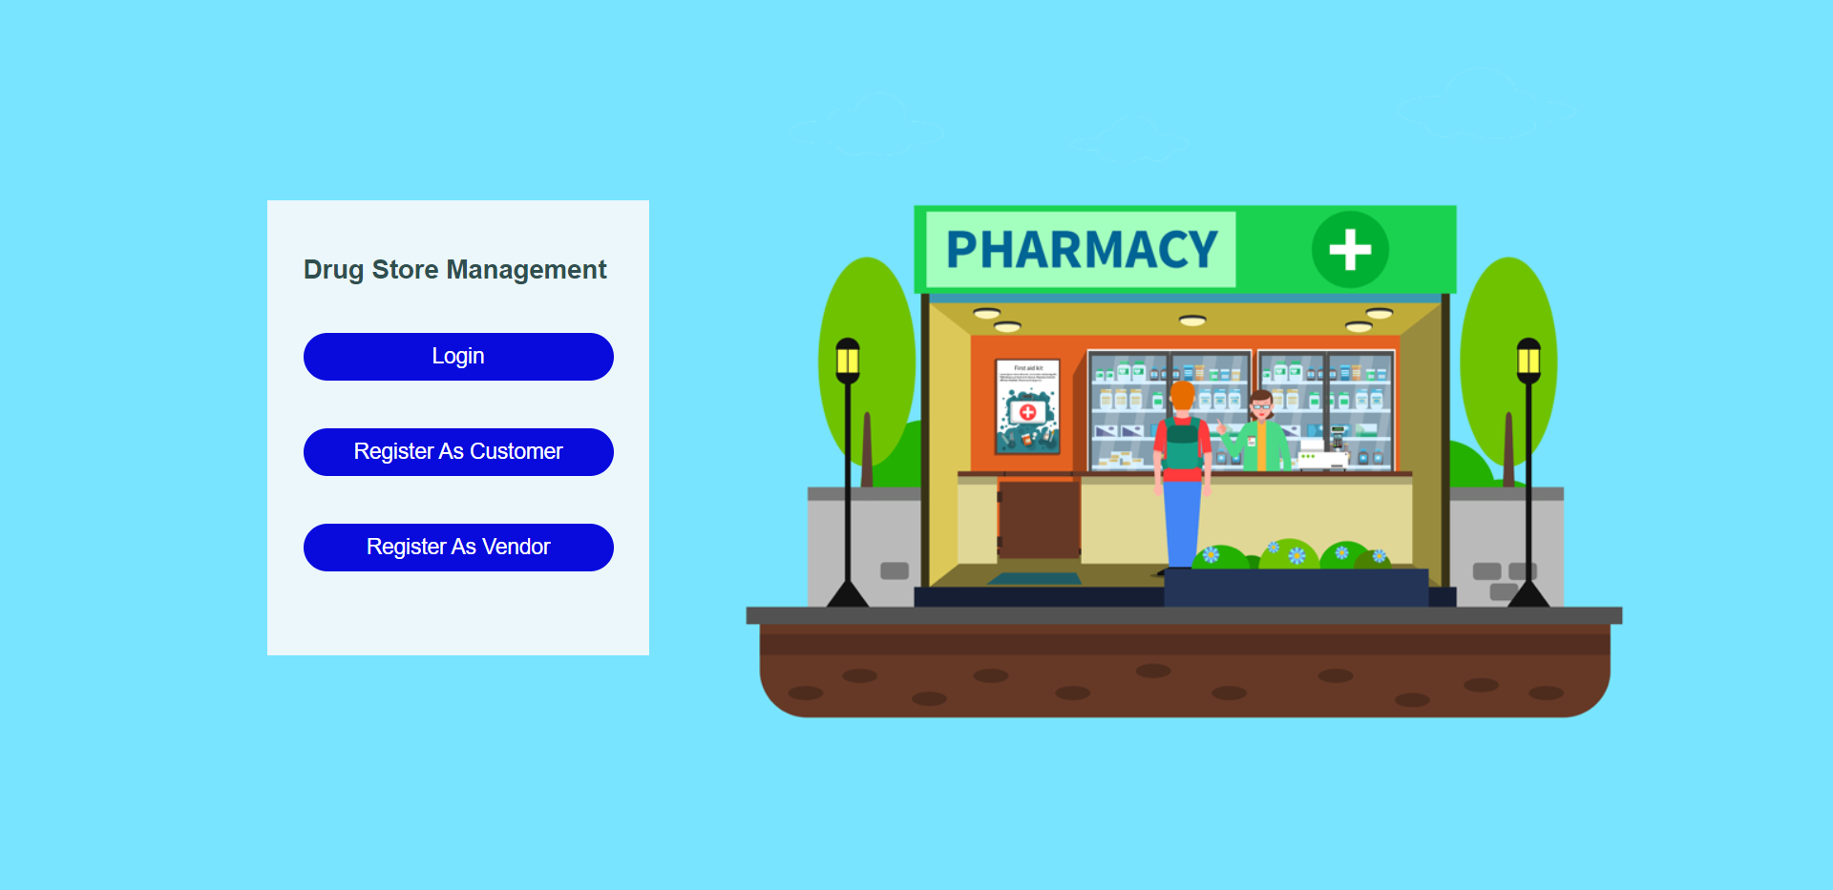

Fig5.2: Login Page

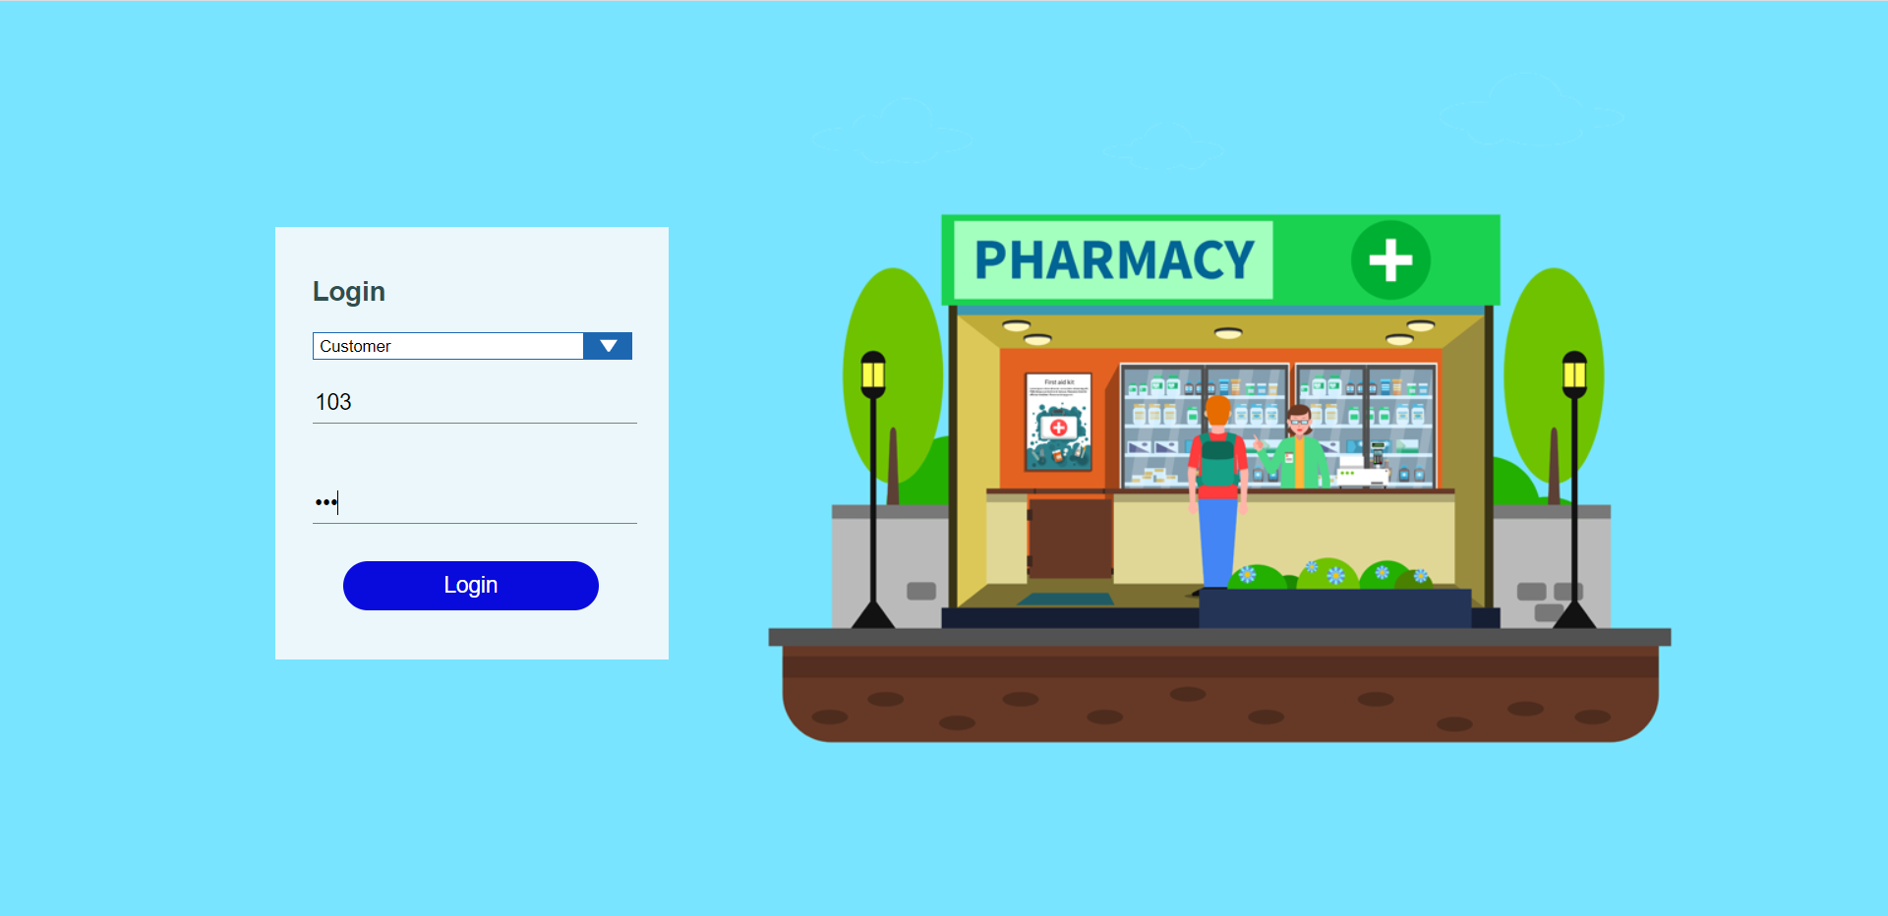

Fig5.3: Register as vendor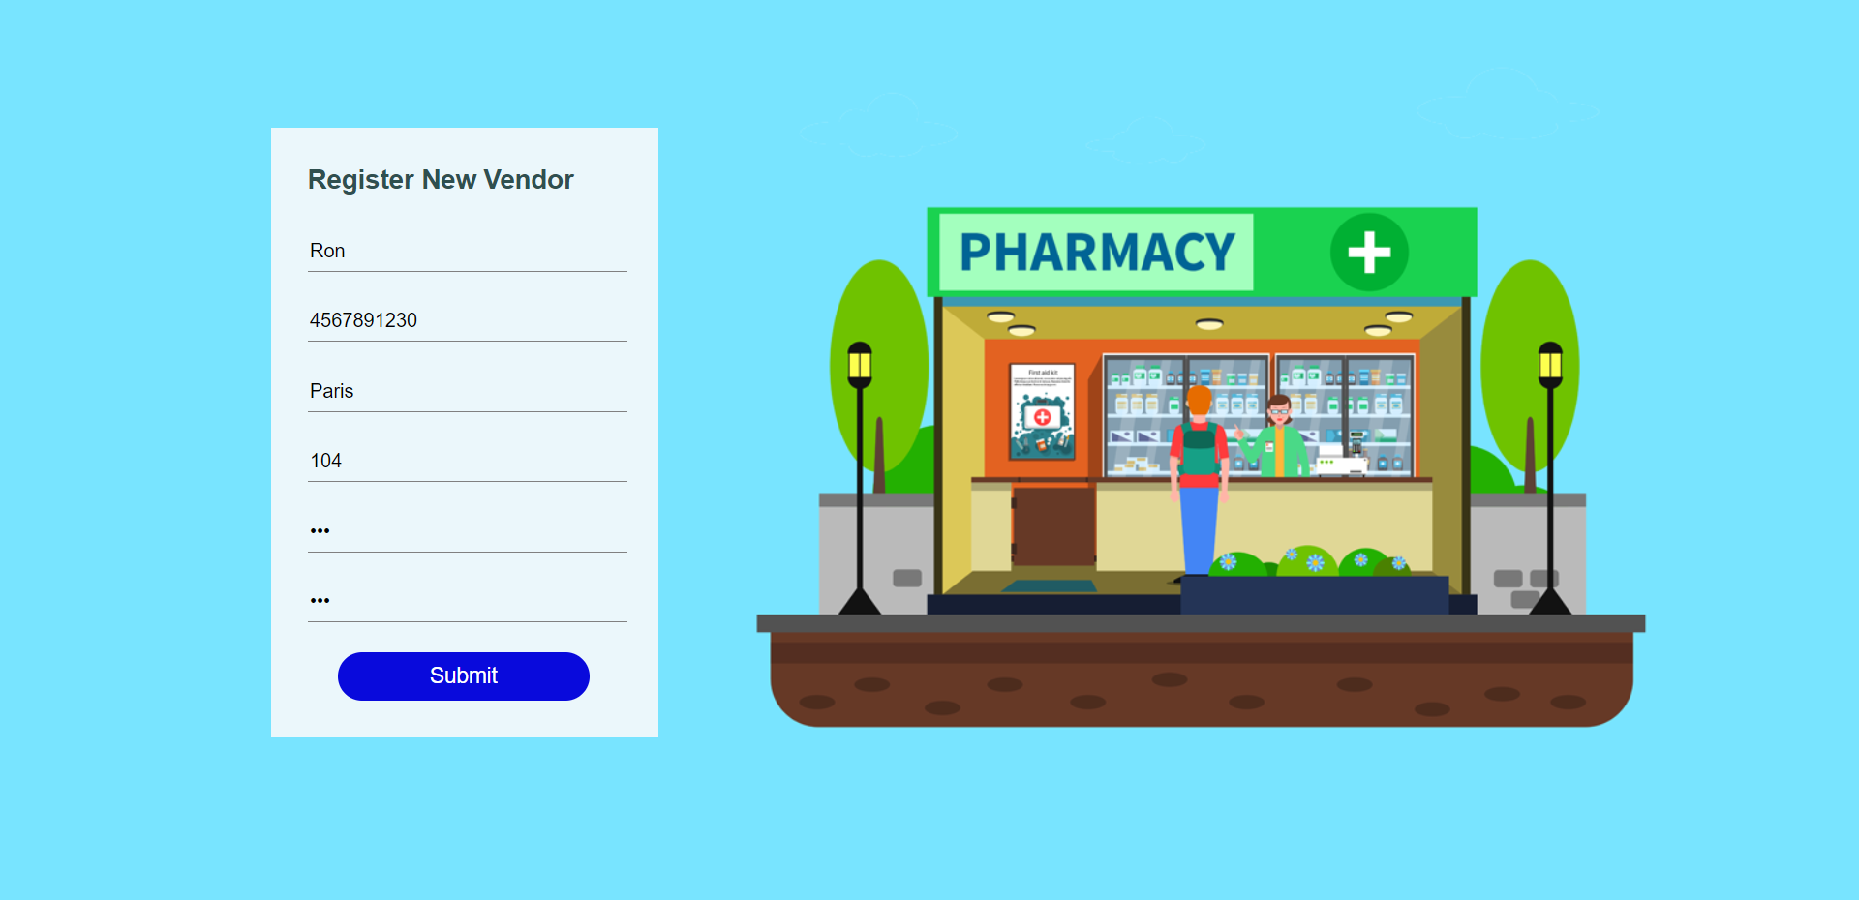

Fig5.4: Vendor Information

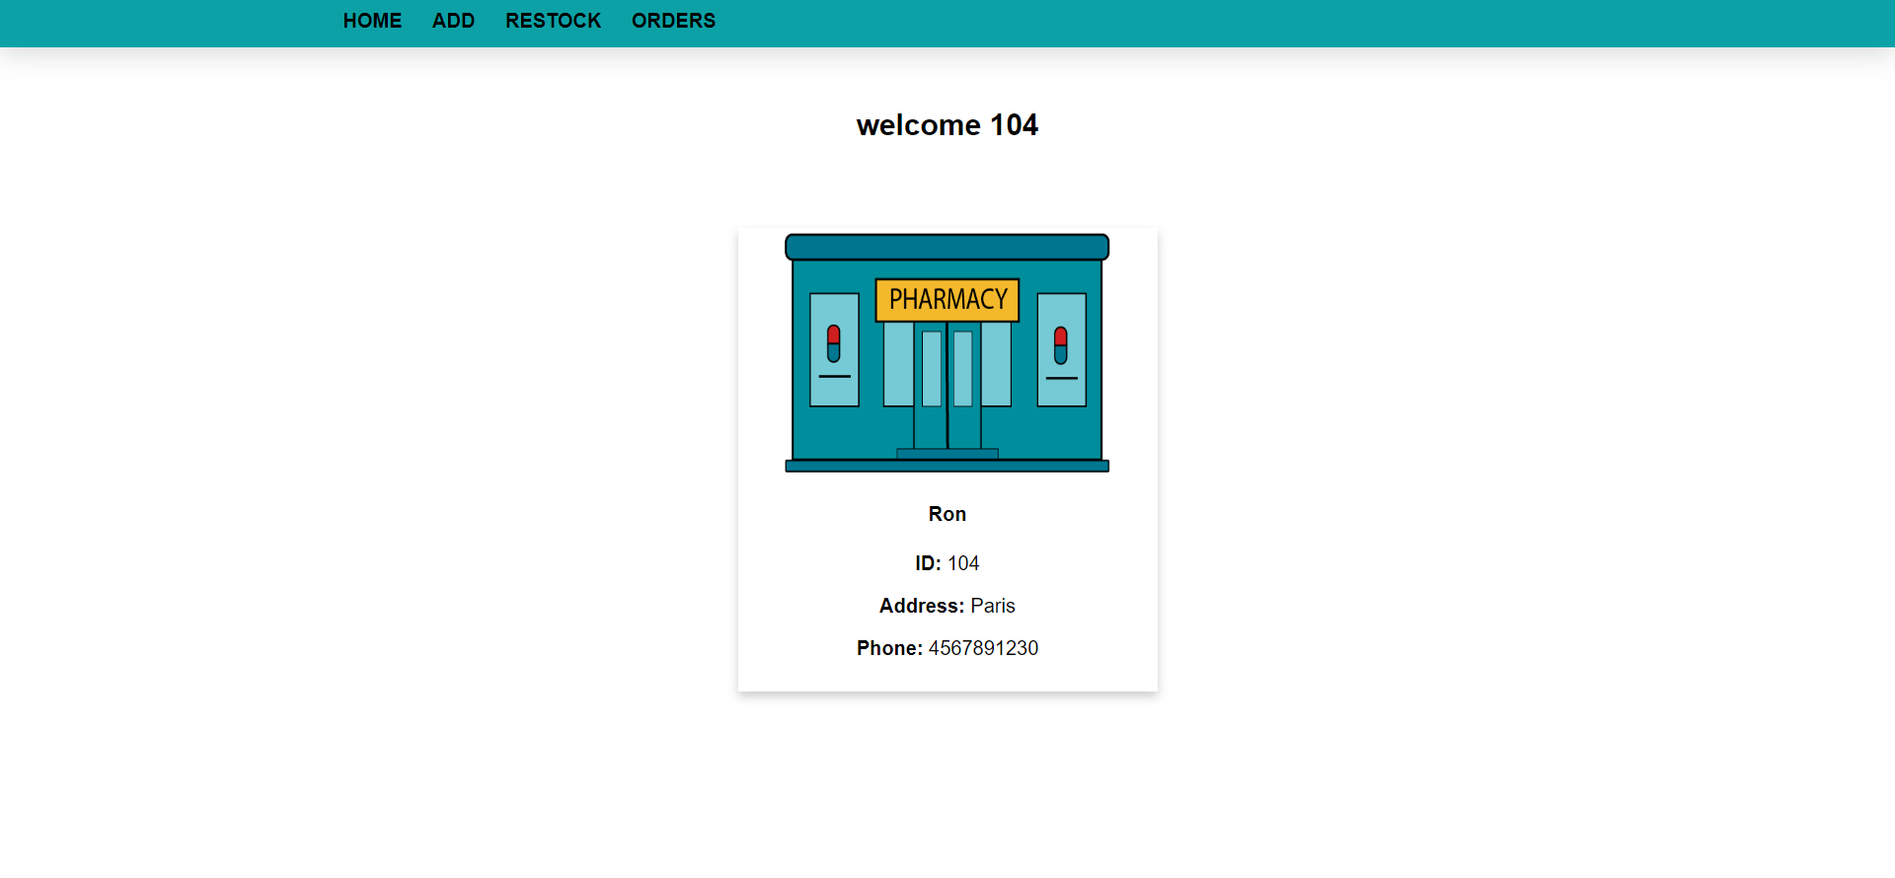

Fig5.5: Adding Products

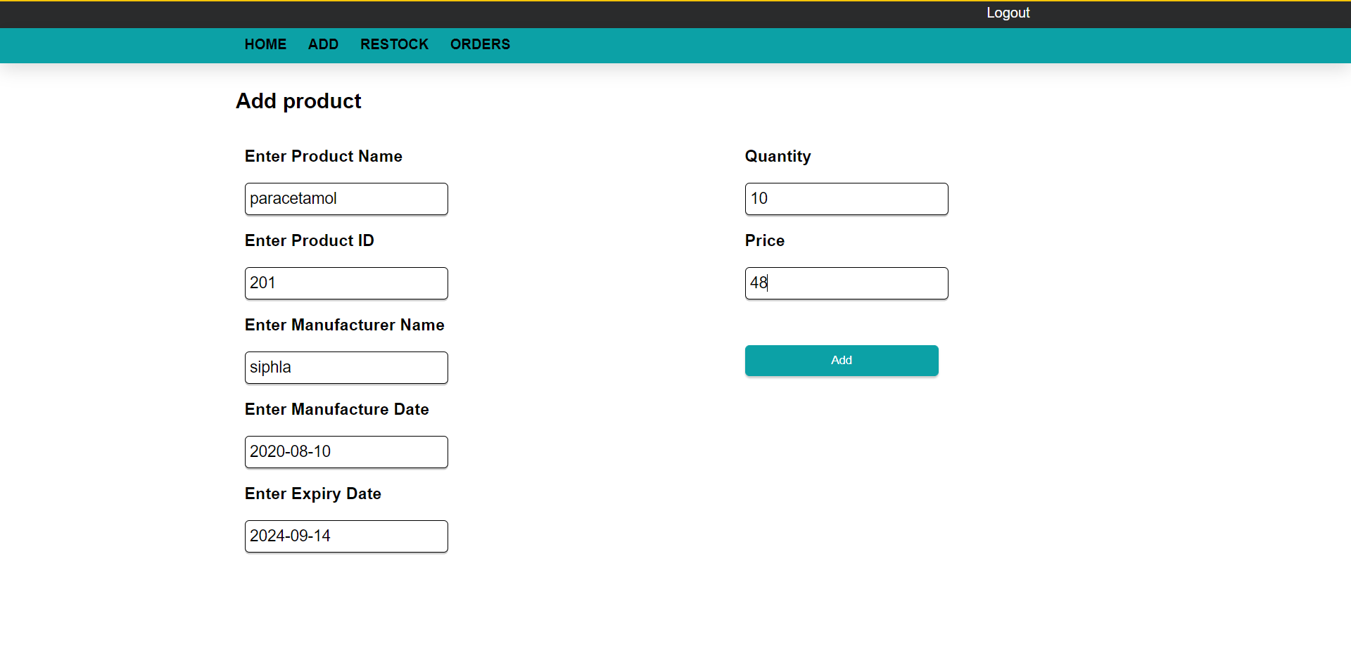

Fig5.6: Restock

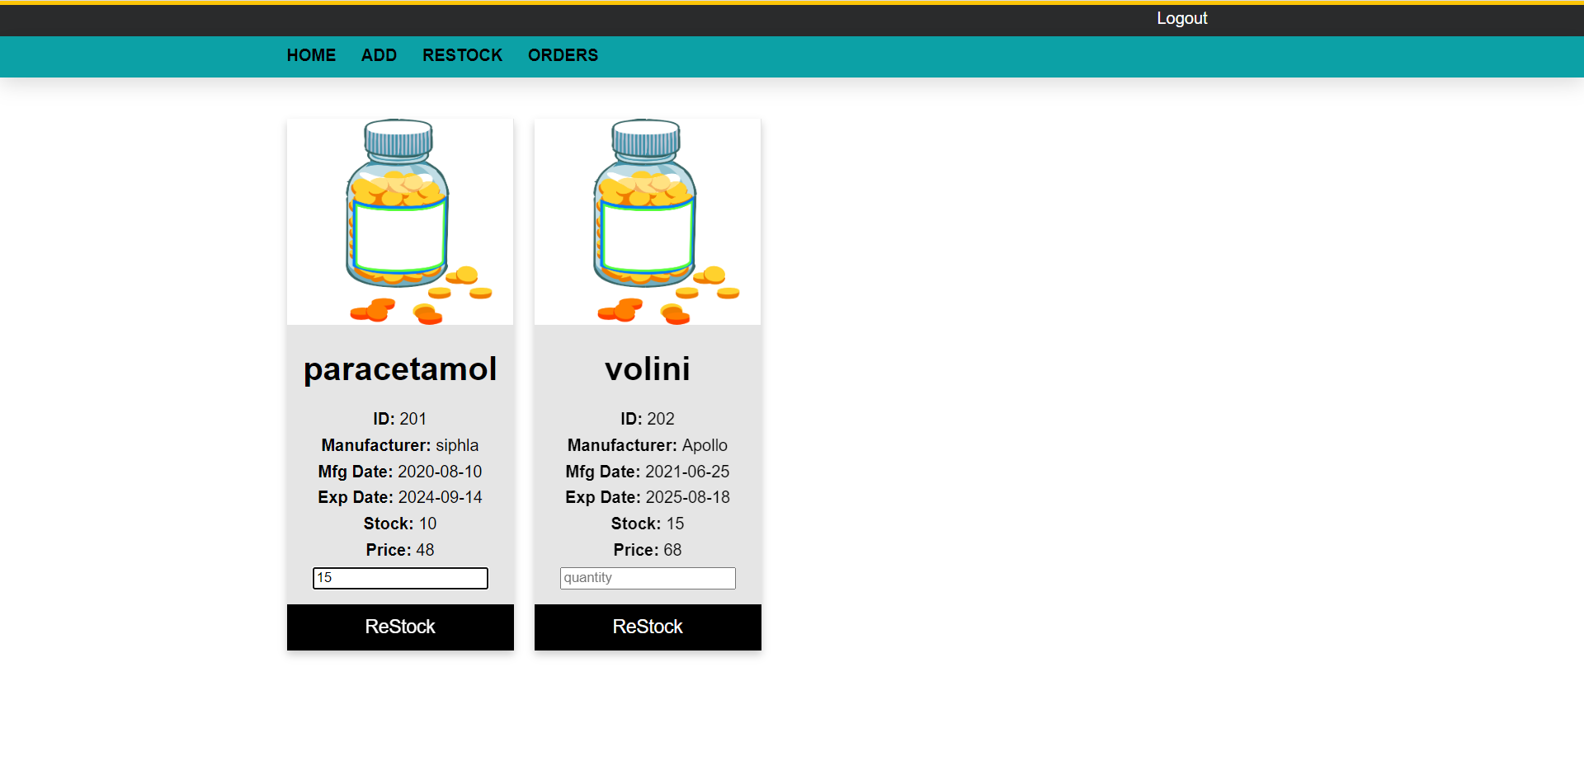

Fig5.7: Order Details for Product

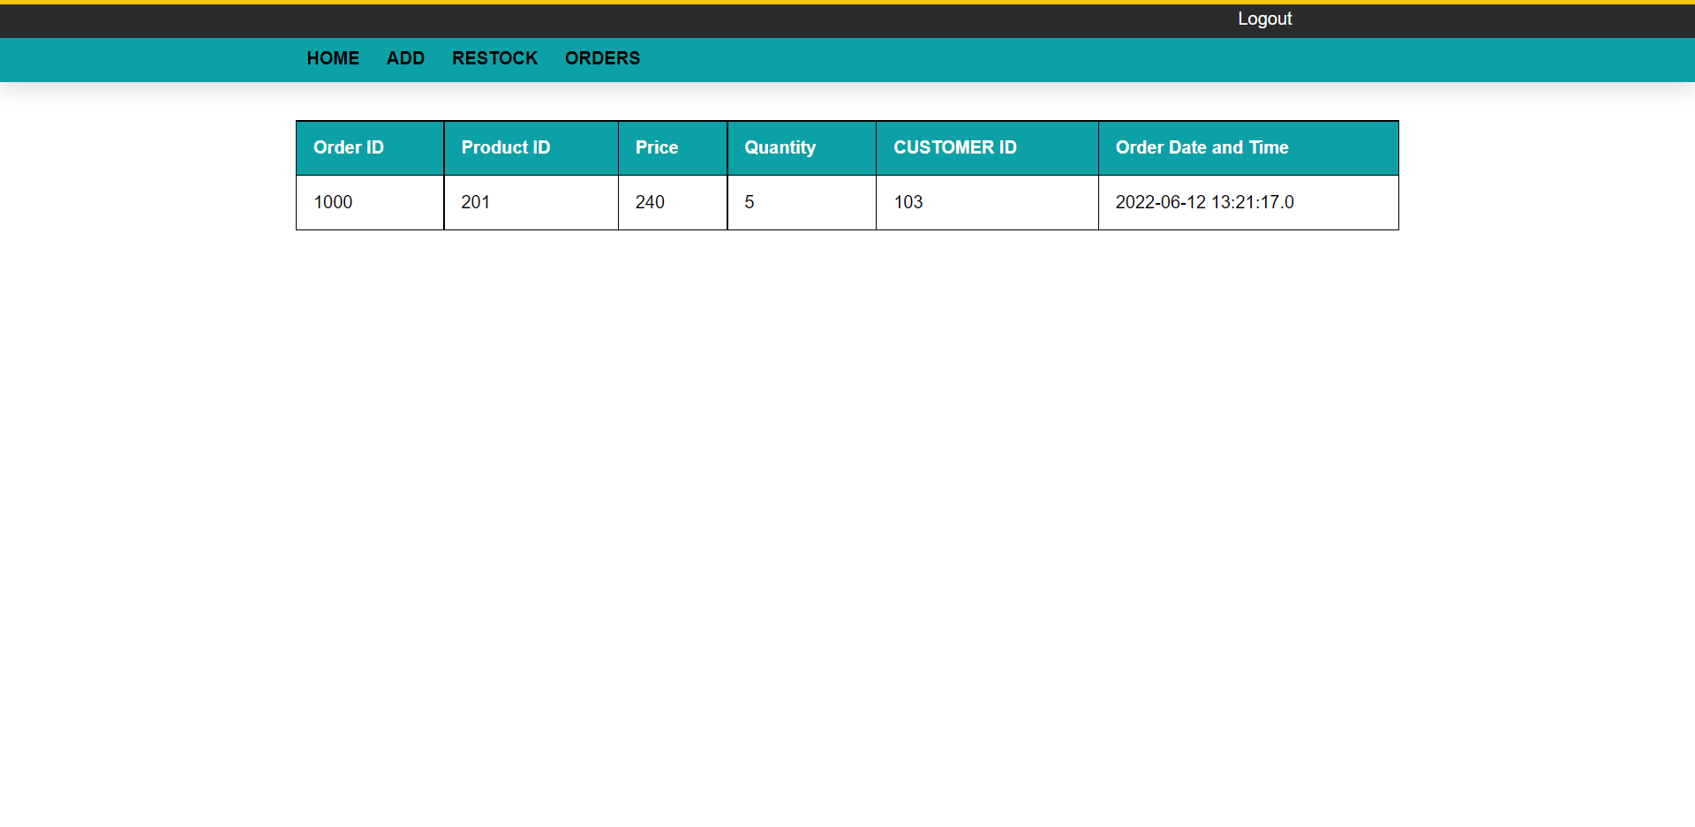

Fig5.8: Register as Customer

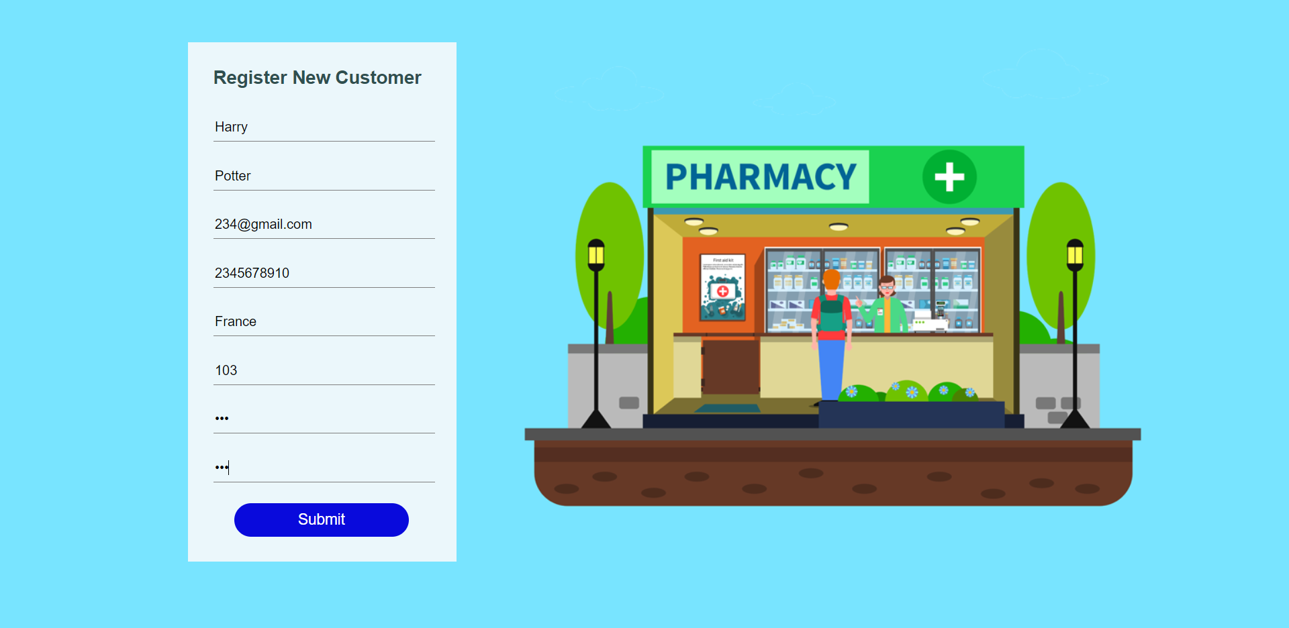

Fig5.9: Customer Information

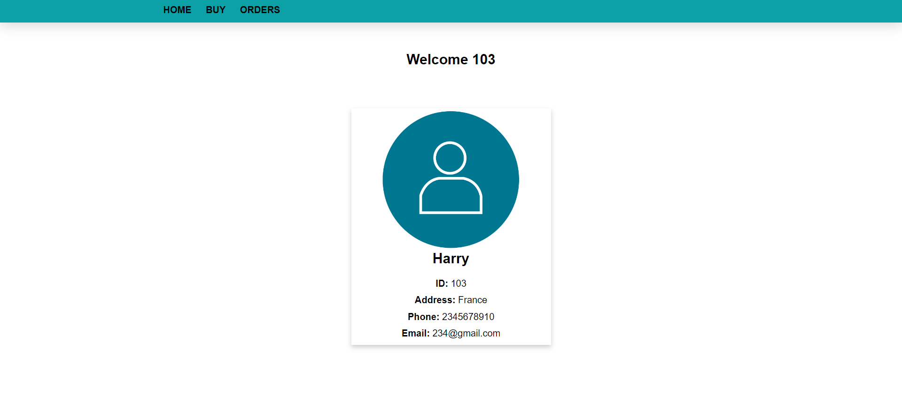

Fig5.10: Purchase page for customer

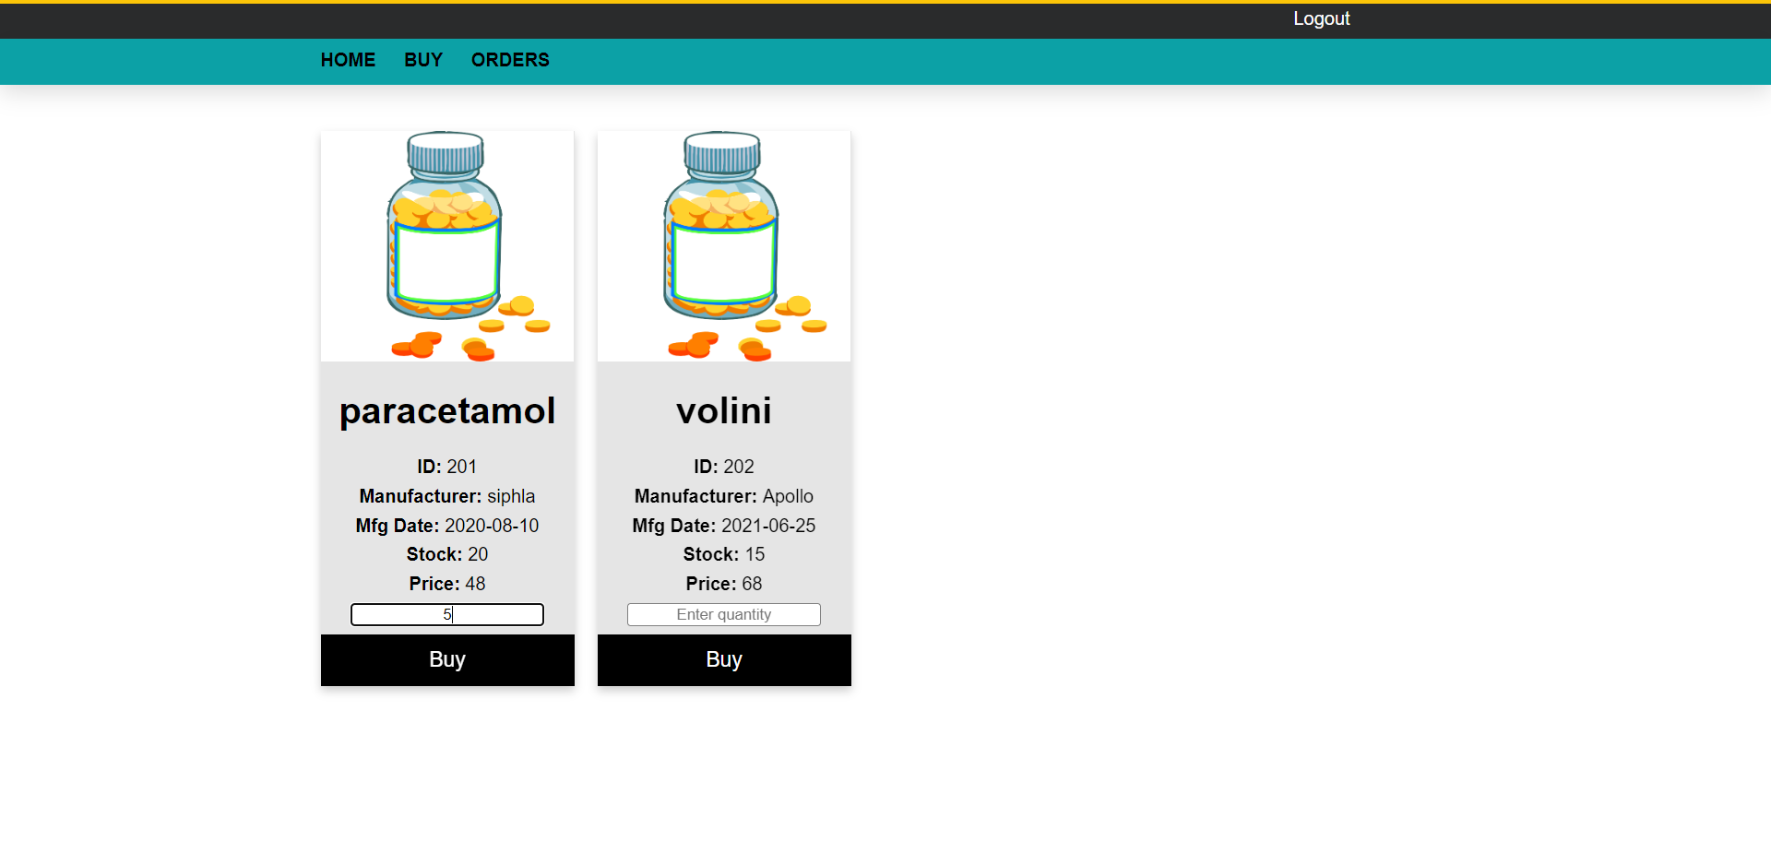

Fig5.11: Order details of Customer

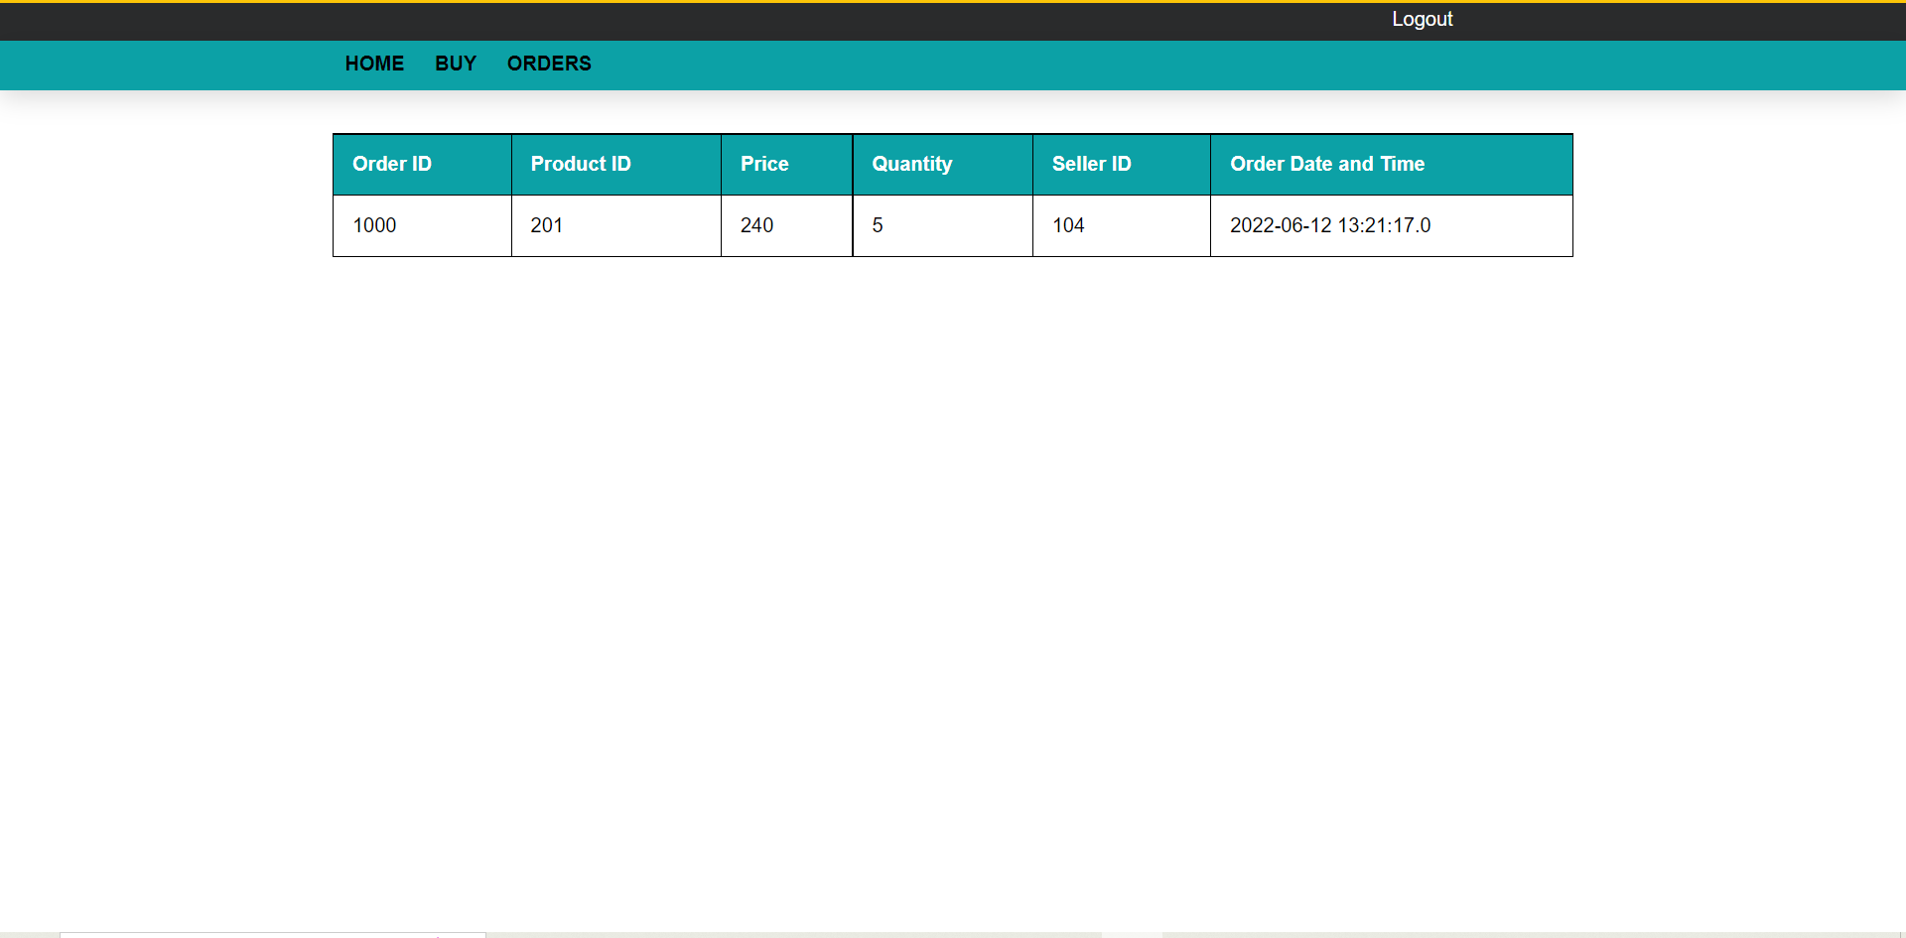

**CHAPTER 6**

**CONCLUSION**

Use of the computers has solved many problems, which are faced while manual calculation. By our system the users easily buy medical products through online and there is no need of travelling to medical shop to get medicines. This application is very helpful for patients with diseases who are unable to physically go to medical store. This application is working properly and meeting to all user requirements. This component can be easily plugged in many other systems.

**FUTURE WORK**

This medical store management software is designed for people who want to manage purchases of medicines online. This project is designed to fulfill the need of the future generation. This project is small package which includes different categories as well as having all possible feature. we have expected that it will be helpful to the customers as well as sellers who wants to sell their products online. We will improve this project in future with cancellation of ordered medicines and will provide online payment options for medicines which are purchased. We are waiting for your future suggestion and encouragement which could make us improve the future programming much better than the one we have carried out.

**CHAPTER 7**

**REFERENCES**

**BOOK:**

* Servelets & JSP – by Budi Kurniawan.

**WEBSITES:**

* www.javapoint.com
* www.geeksforgeeks.com
* www.programiz.com
* www.w3schools.com